

AEO PROPOSAL

Featuring Aidi







Executive Summary Proposal

The interface design team's idea is meant to bring feedback to the forefront with a natural interface (artificial intelligence similar to Siri) called Aidi. Aidi's algorithm collects data from reviews on items and gives the user exactly the information he or she may be looking for. Aidi organizes and interprets information from product reviews, social media, and any other user feedback it can collect to bring the information to the user. Aidi grows with the user and looks at his or her social media to understand the user's style, make recommendations, and even knows the weather in order to make recommendations accordingly. This natural interface is able to provide users with fit and feel of products during online shopping experiences, increase online purchase confidence, and reduce returns.

Foundation Goal

American Eagle Outfitters (AEO) is looking for a solution to a current problem in online shopping—generating a sense of the fit and feel of their clothing without the physicality of being in the store. A mandatory of this solution, or desired benefit of the solution, is to create micro-moments for the users in order to create a closer relationship between the brand and its customers. The interface designers of Duquesne University developed a solution to this problem in a step-by-step processes that included: user research, primary and secondary research, conceptualization, developing personas, developing scenarios, developing a workflow diagram, creating wireframes and visual comps, and finally usability testing/user feedback.

User Research

In initial research, it was important to gain a comprehensive understanding of American Eagle's target audience. American Eagle’s core demographic is high school and college age students, both male and female, between ages 15 and 25. In terms of psychographics, this audience is adventurous, fun, and tech-savvy. In regards to online shopping, one study suggests that 88% of consumers say they trust online reviews as much as personal recommendations (vs. 79% in 2013). They often look at these reviews on their mobile devices while shopping in stores, or while shopping online, and bad reviews/lack of reviews can ruin sales and trust in the brand. These were significant findings for the interface design team, and inspired them to consider developing an interface that worked with both reviews and personal recommendations.

The interface designers developed a preliminary survey, in which 30 people participated. All were between the ages of 18 and 29. 70% of those surveyed were females, and 30% were male. This illustrates that females are more interested in going shopping and discussing shopping experiences than males. When asked about their confidence (or lack there of) in shopping online, 77% responded that they are hesitant purchasing clothes online because they cannot get the fit and feel of physically trying on clothes in a store.

In a second, follow-up survey, 18 people participated. In this survey, respondents answered what major issues they run into during an online shopping experience. One major problem was that consumers had to return clothes often, and the return process is a hassle. Another problematic factor is not having the ability to try the clothes on and having to "blindly" purchase clothes without knowing exactly how they will fit until the products are delivered. Consumers cannot have confidence in their online purchase because every brand fits differently, and even within brands, different products may fit them differently. Again, not being able to try clothes on diminishes online purchase confidence. When asked what kinds of questions people ask themselves during a shopping experience, respondents listed the following:

* + What sizes does this product come in?
  + How will this product fit me?
  + Does this product shrink in the wash or stretch after wearing?
  + What kind of material is this product and how will it feel?
  + Can I show this to my: mom, boyfriend, sister, friend, etc.?
  + What items are on sale/clearance?
  + What would this item of clothing look good with?

With a concept already in mind about a virtual personal shopping assistant, the interface design team also asked those surveyed about what kind of suggestions they would like from said assistant. Participants responded that they would:

* + Want to know how the material feels
  + General style suggestions (color combos, etc.)
  + Want to take into consideration previous purchases
  + Trending styles and what is most popular
  + Want suggestions based on the weather outside
  + Suggestions based on the item they are interested in purchasing

In a Likert-scale format, the participants were also prompted to say whether or not they would like and benefit from a virtual shopping assistant. 9 respondents (50%) said they would feel somewhat comfortable, and the other 9 (50%) said they would feel very comfortable. None of the respondents said they would not feel comfortable, so the interface design team took this set of results as an initiative to officially begin creating a natural interface, Aidi.

Key Considerations

The interface design team analyzed the results of their surveys and secondary research articles in accordance with the mandatories requested by American Eagle Outfitters in order to get a sense of direction for the project. With all of these factors in mind, the designers made a list of needs and ideas:

* Create a sense of fit and feel during online shopping
* Develop micro-moments between user and interface/brand
* Conjoin reviews and personal shopping
* Utilize as few pain-points as possible
* Allow users to share their shopping experience with close friends and family
* Increase consumer confidence in online shopping experiences
* Utilize a natural interface

How it Works

Aidi would be the next generation in machine learning. Following in the wake of predecessors like Siri, Google, and Amazon Echo. Aidi uses deep learning to create profiles of users. Aidi uses every piece of information it can from a user’s style, the color of their eyes, and even the weather outside to make judgements and suggestions.

Deep learning works in the same as your brain does. Every piece of information is put through a process using all data available.

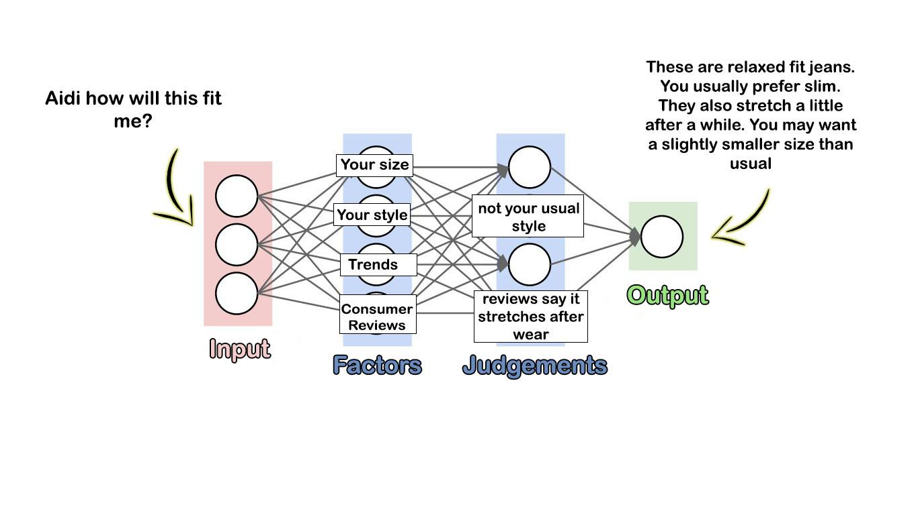

Deep learning is actually a series of neural network processes that weigh factors of data against other factors. Redundantly processing and weighing option gives Aidi the best chances of giving users exactly the information they are looking for.

Aidi Key Features

Aidi will collect metadata over time from the user in order to generate an understanding of the user’s style, likes, dislikes, body features/sizes, etc. Aidi will also take into consideration reviews on American Eagle’s app to compile accurate recommendations for the user.

* **Inventory**
  + Aidi remembers previous purchases and clothes the user owns, allowing Aidi to have more accurate style and size recommendations.
* **Search by Voice**
  + Ask Aidi and search specific parameters easily and accurately
  + Ask Aidi about:
    - Sales
    - Specific items of clothes, colors, and sizes
* **Sharing**
  + Ask Aidi to share a particular product via messaging or social media
    - ie. A user likes a shirt and wants to show their friend to get their friend’s opinion via iMessage. Aidi would be able to set up that interaction for the user
* **Text or Chat**
  + Most users don’t want to carry on a conversation with their phone in public. As a solution to this potential problem, users will be able to click a chat icon to have a messaging conversation with Aidi (like texting).
* **Style Recommendation**
  + Tell Aidi you have a party to go to and Aidi make recommendation based on what you own, the weather, and the type of event.
    - Example: Aidi, I have a birthday party tonight what should I wear?
    - Aidi: Dark jeans and your blue button up… but take your grey sweater just in case, it will get cold later.
* **Customer Review-Based Recommendation**
  + Aidi organizes and interprets information in reviews to guide recommendations.
    - *Example→ User: Aidi, will these pants fit?*
    - *Aidi: They’re slim fit, not your usual style and reviews say they do shrink in the wash. If you want them, you should buy a slightly larger size.*
  + Aidi also asks the user for customer reviews 2 weeks after purchasing a product via a notification, and rewards the user for submitting a review.
    - *Example→ Aidi: Hi, ________. It’s been a couple weeks since you purchased the high-rise black jeggings. How do you like your purchase?*
    - The user would then be able to text or speak to answer, and Aidi would thank the user and then give them AEO reward points.

The Benefit Cycle

Aidi makes reviews rewarding by offering the benefit of small prizes for completing rewards, while also reminding the user these reviews make Aidi more capable of giving the user more accurate, personalized results. This type of rewards system would be mutually beneficial for the user, Aidi, and American Eagle Outfitters.

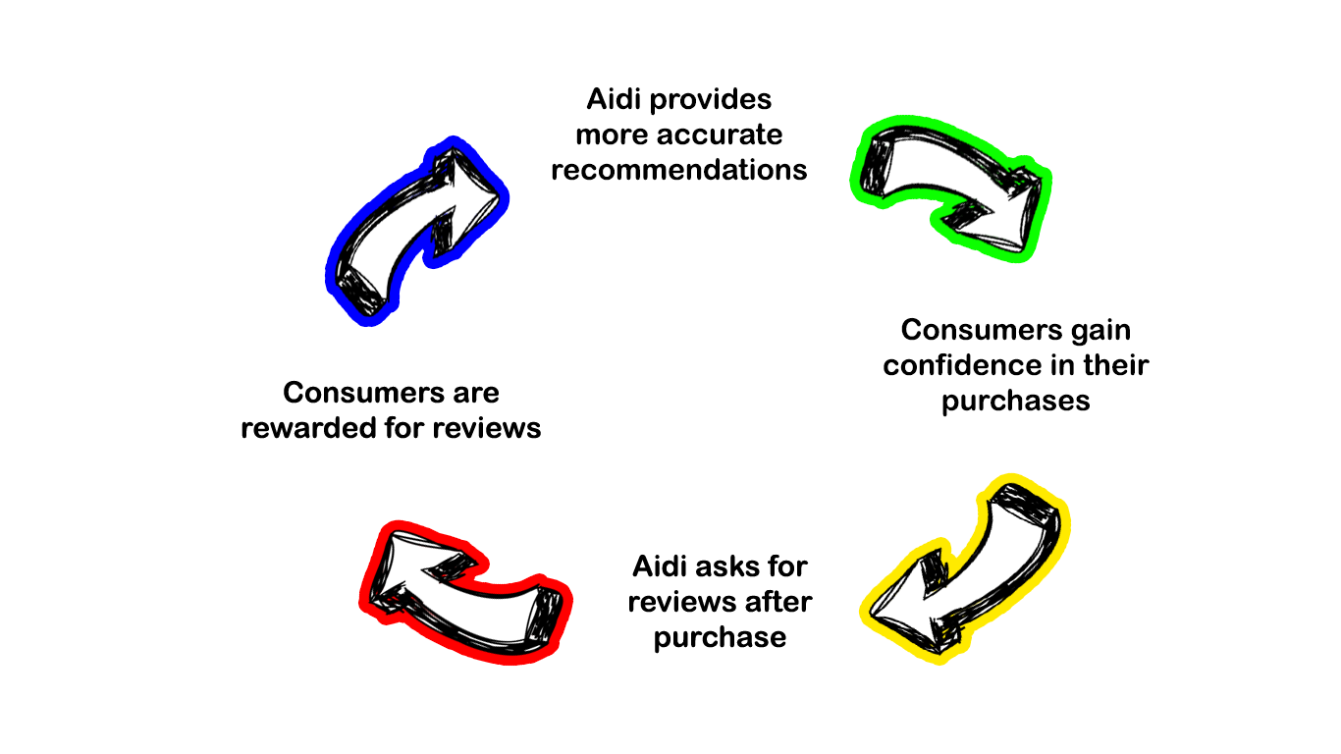

Pros

* Hands-fee, reduces pain points
* Adds personalized touch
* Increases product reviews
* Increases consumer confidence
* Reduced returns

Cons

* Users may not be in the right setting to speak out loud with their assistant.
* **Solution:** have a messagingfeature so users can interact with their shopping assistant as they would via text conversation.
* Users may not be comfortable sharing enough information to allow assistant to make accurate decision
* **Solution:** Allow users to disengage personalization but retain search features and other functions

Scenario 1: George's Sweater

George is looking for something warm and fashionable that he can wear but does not want to spend over 50 dollars. Normally George can open the app, select “men’s”, then select “tops”, then “sweaters”, decide the style of sweater, browse selections to see if they are in his price range, and finally find a sweater at the price he is looking for.

Aidi makes his search quick and easy by asking for exactly what he wants. The more descriptive George is, the more focused Aidi search becomes, allowing him to find exactly what he is looking for.

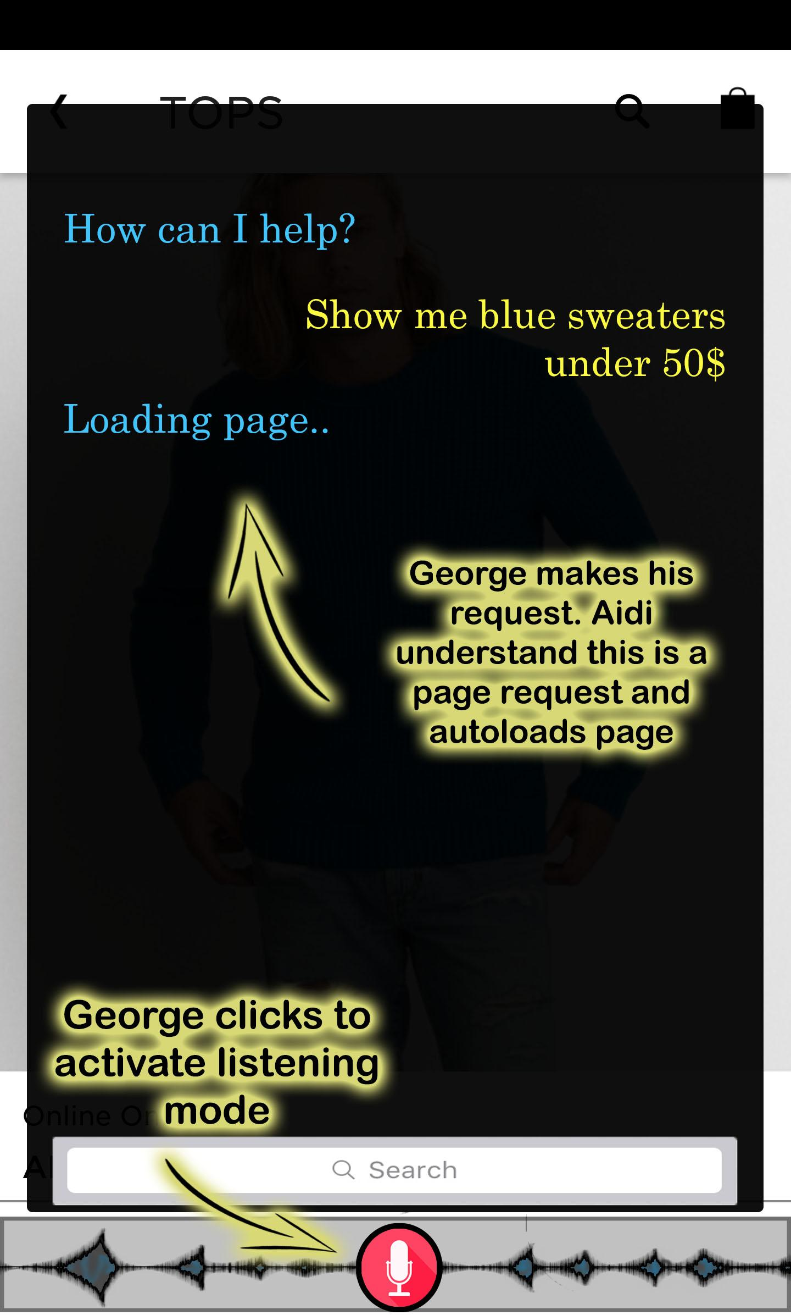 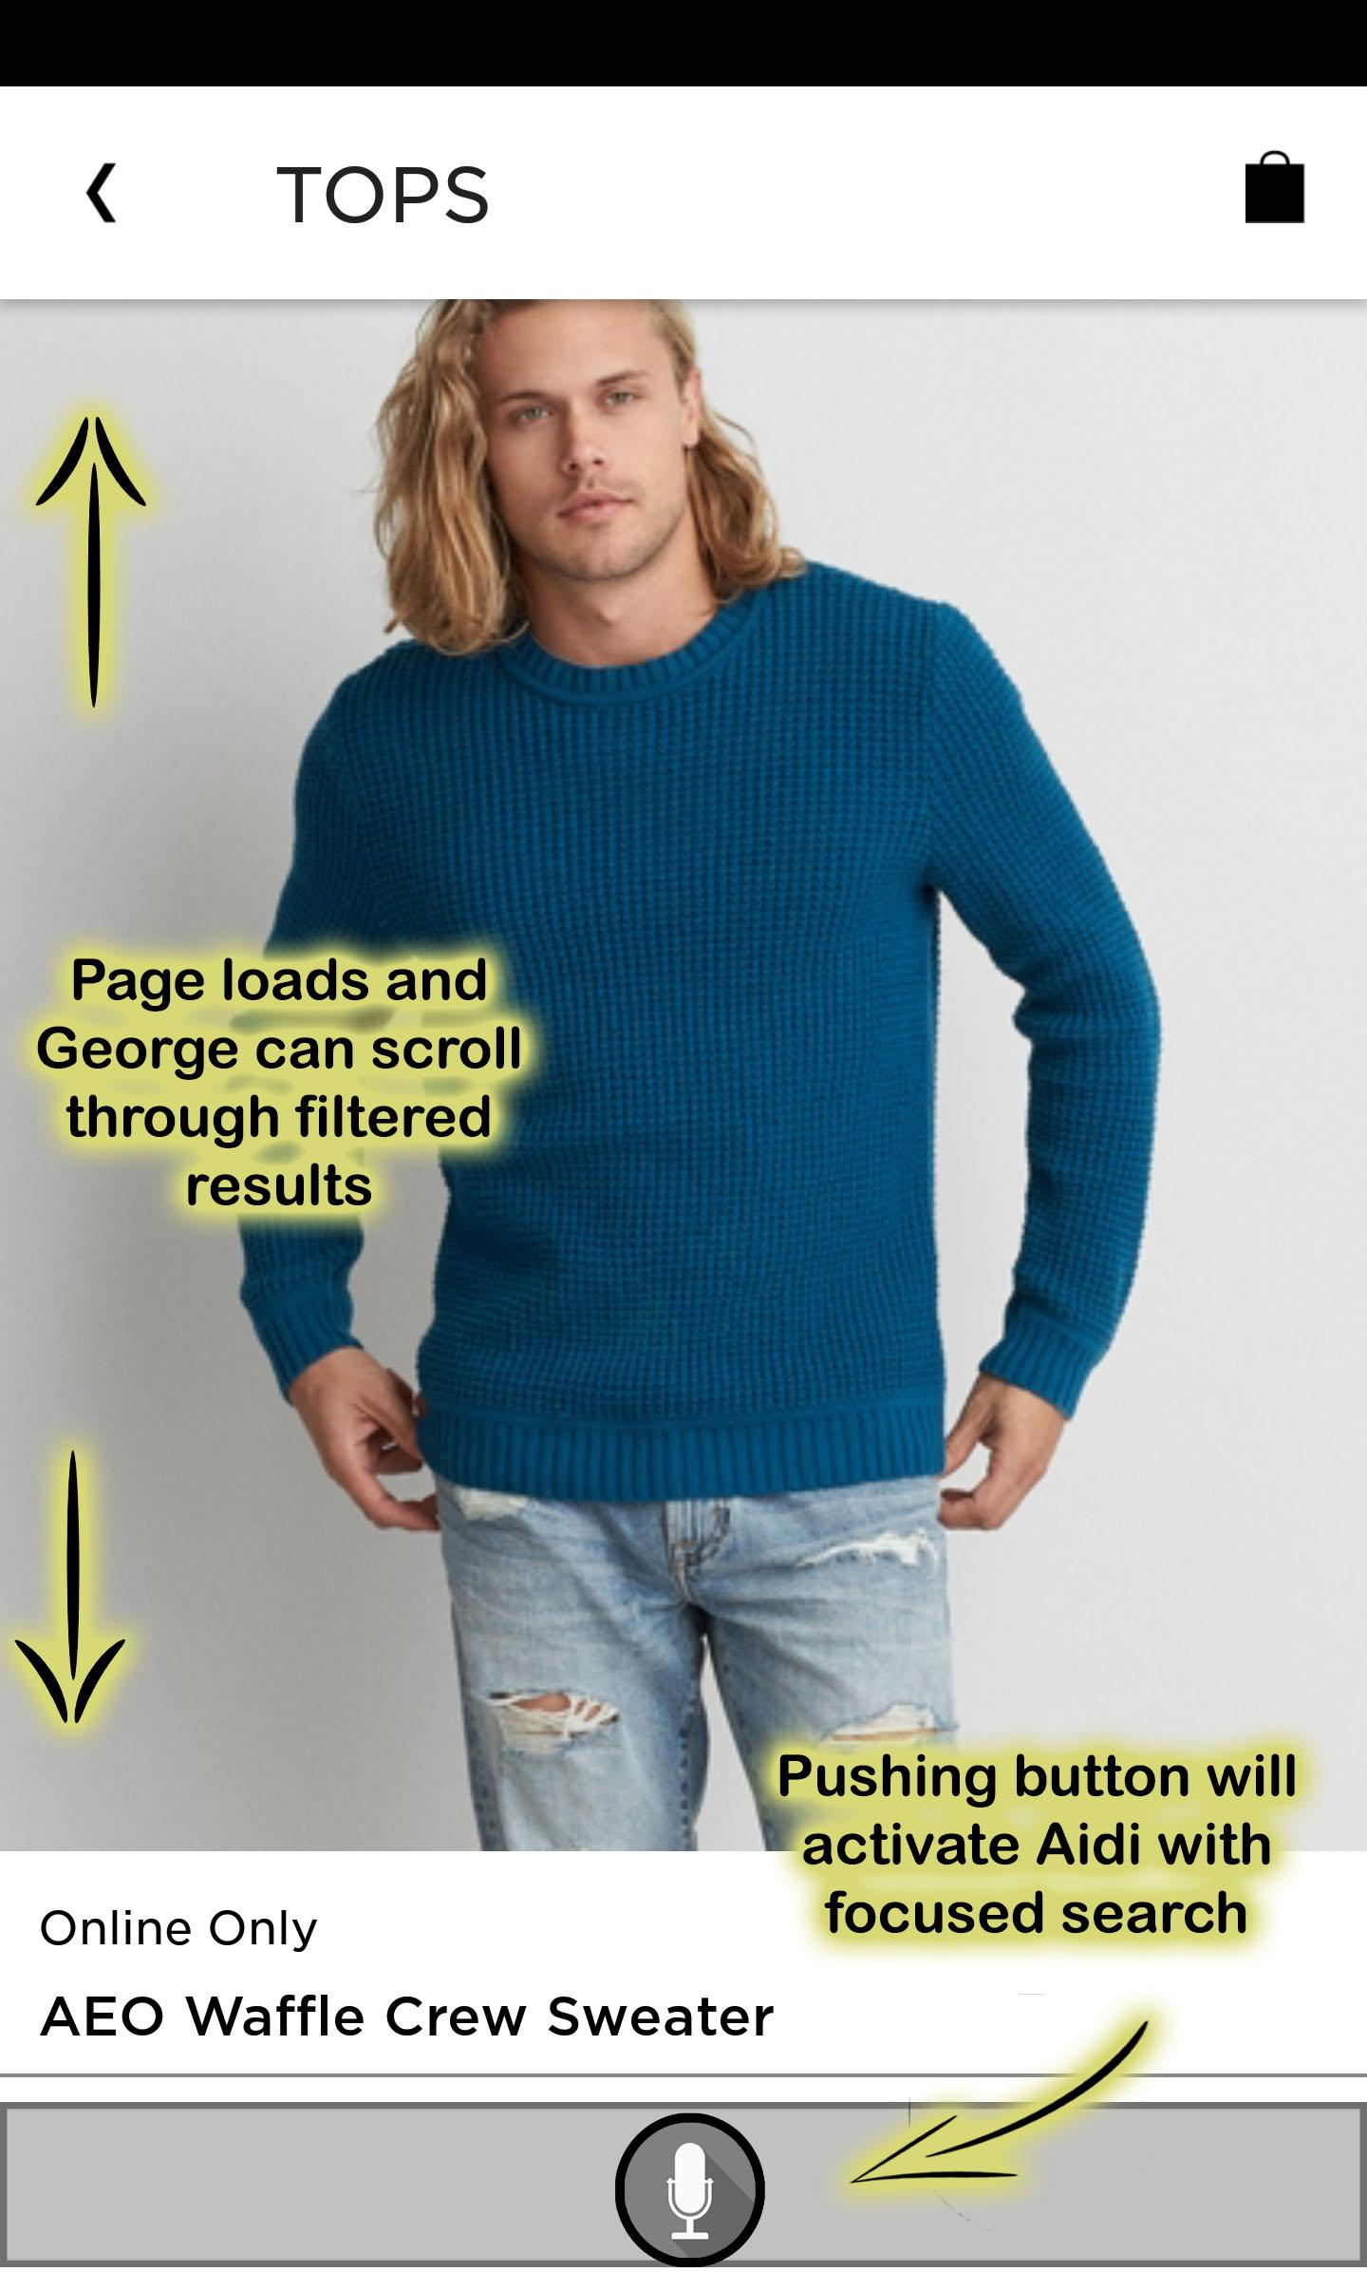

Once George has found a sweater he likes he then get a better idea of how it might fit and feel by asking a few simple questions. This allows George to be completely confident that he made the right decision.

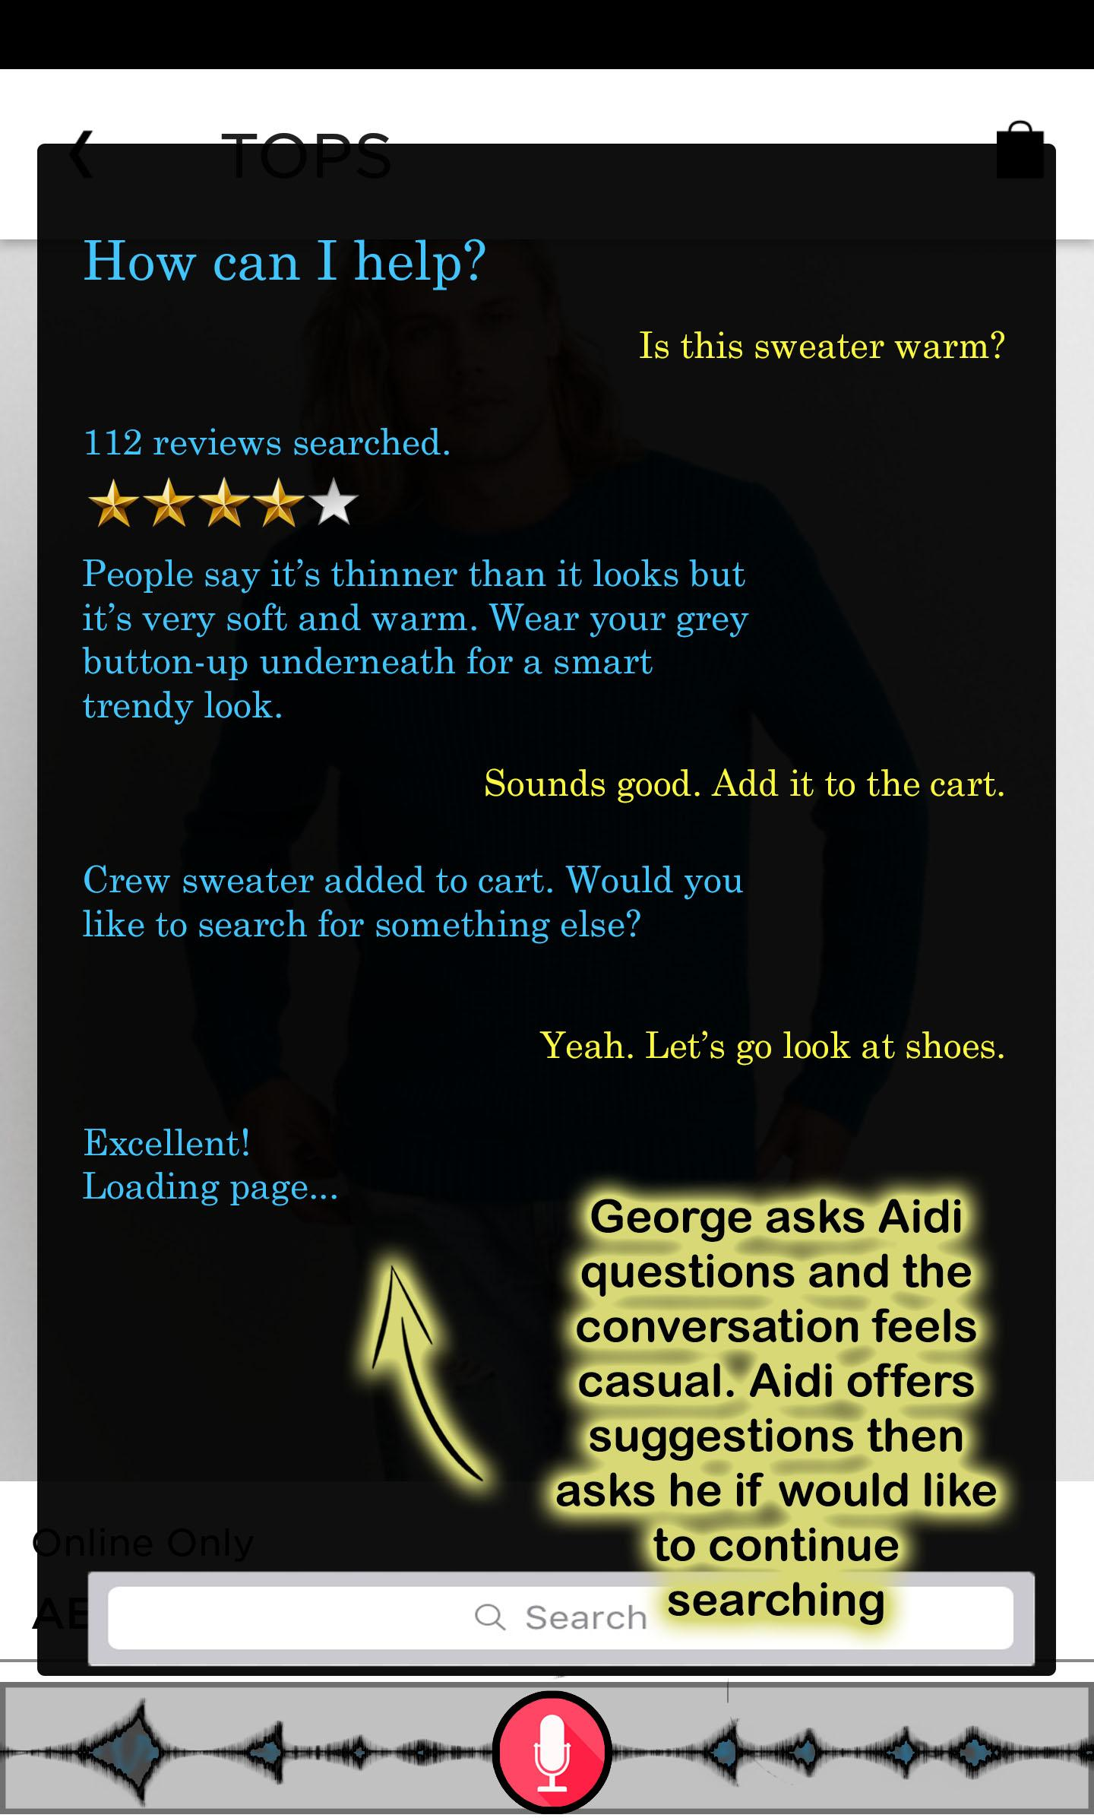

Scenario 2: Megan's Christmas List

Megan is online Christmas shopping and comes across a cardigan she thinks her mom would love. She wants to send it to her and see what she thinks. She quickly asks Aidi to send her mom a text and the message is automatically generated with ratings and a link.

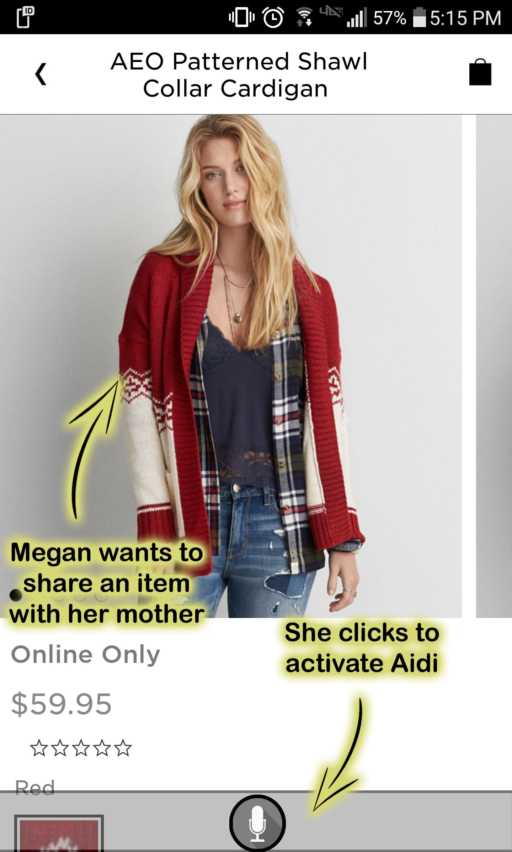 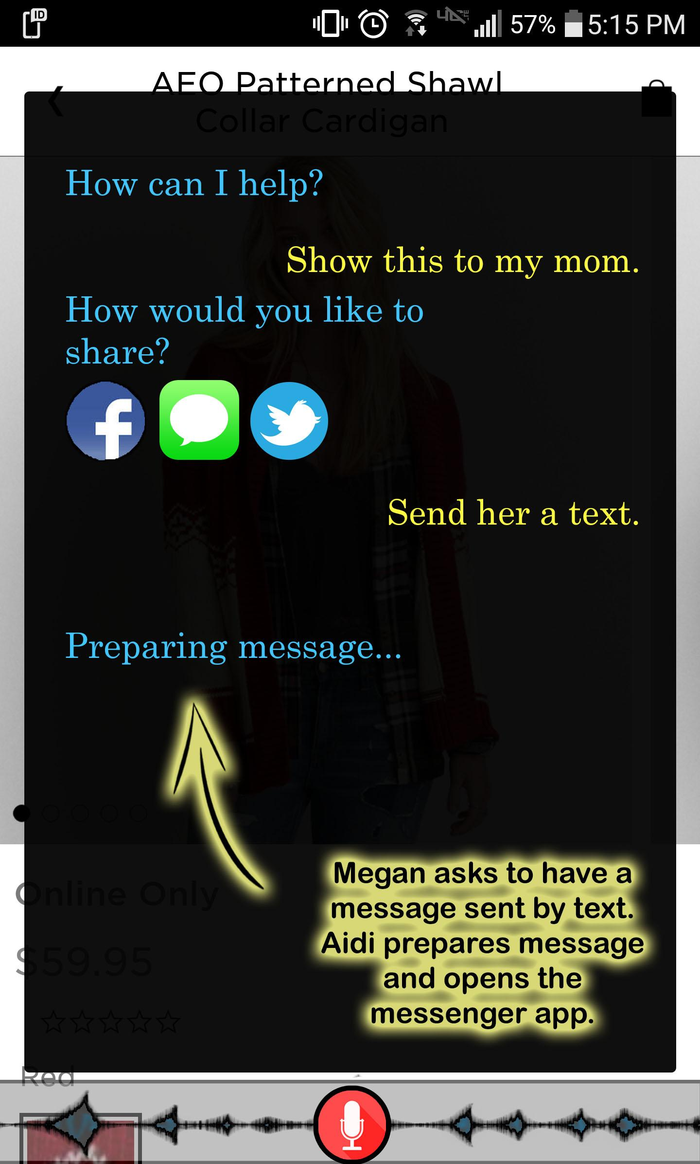

Megan’s mom will get a text with a link. Following the link will take her directly to American Eagle’s page where Aidi will be able to answer any questions she might have about the material, the fit, and other color options.

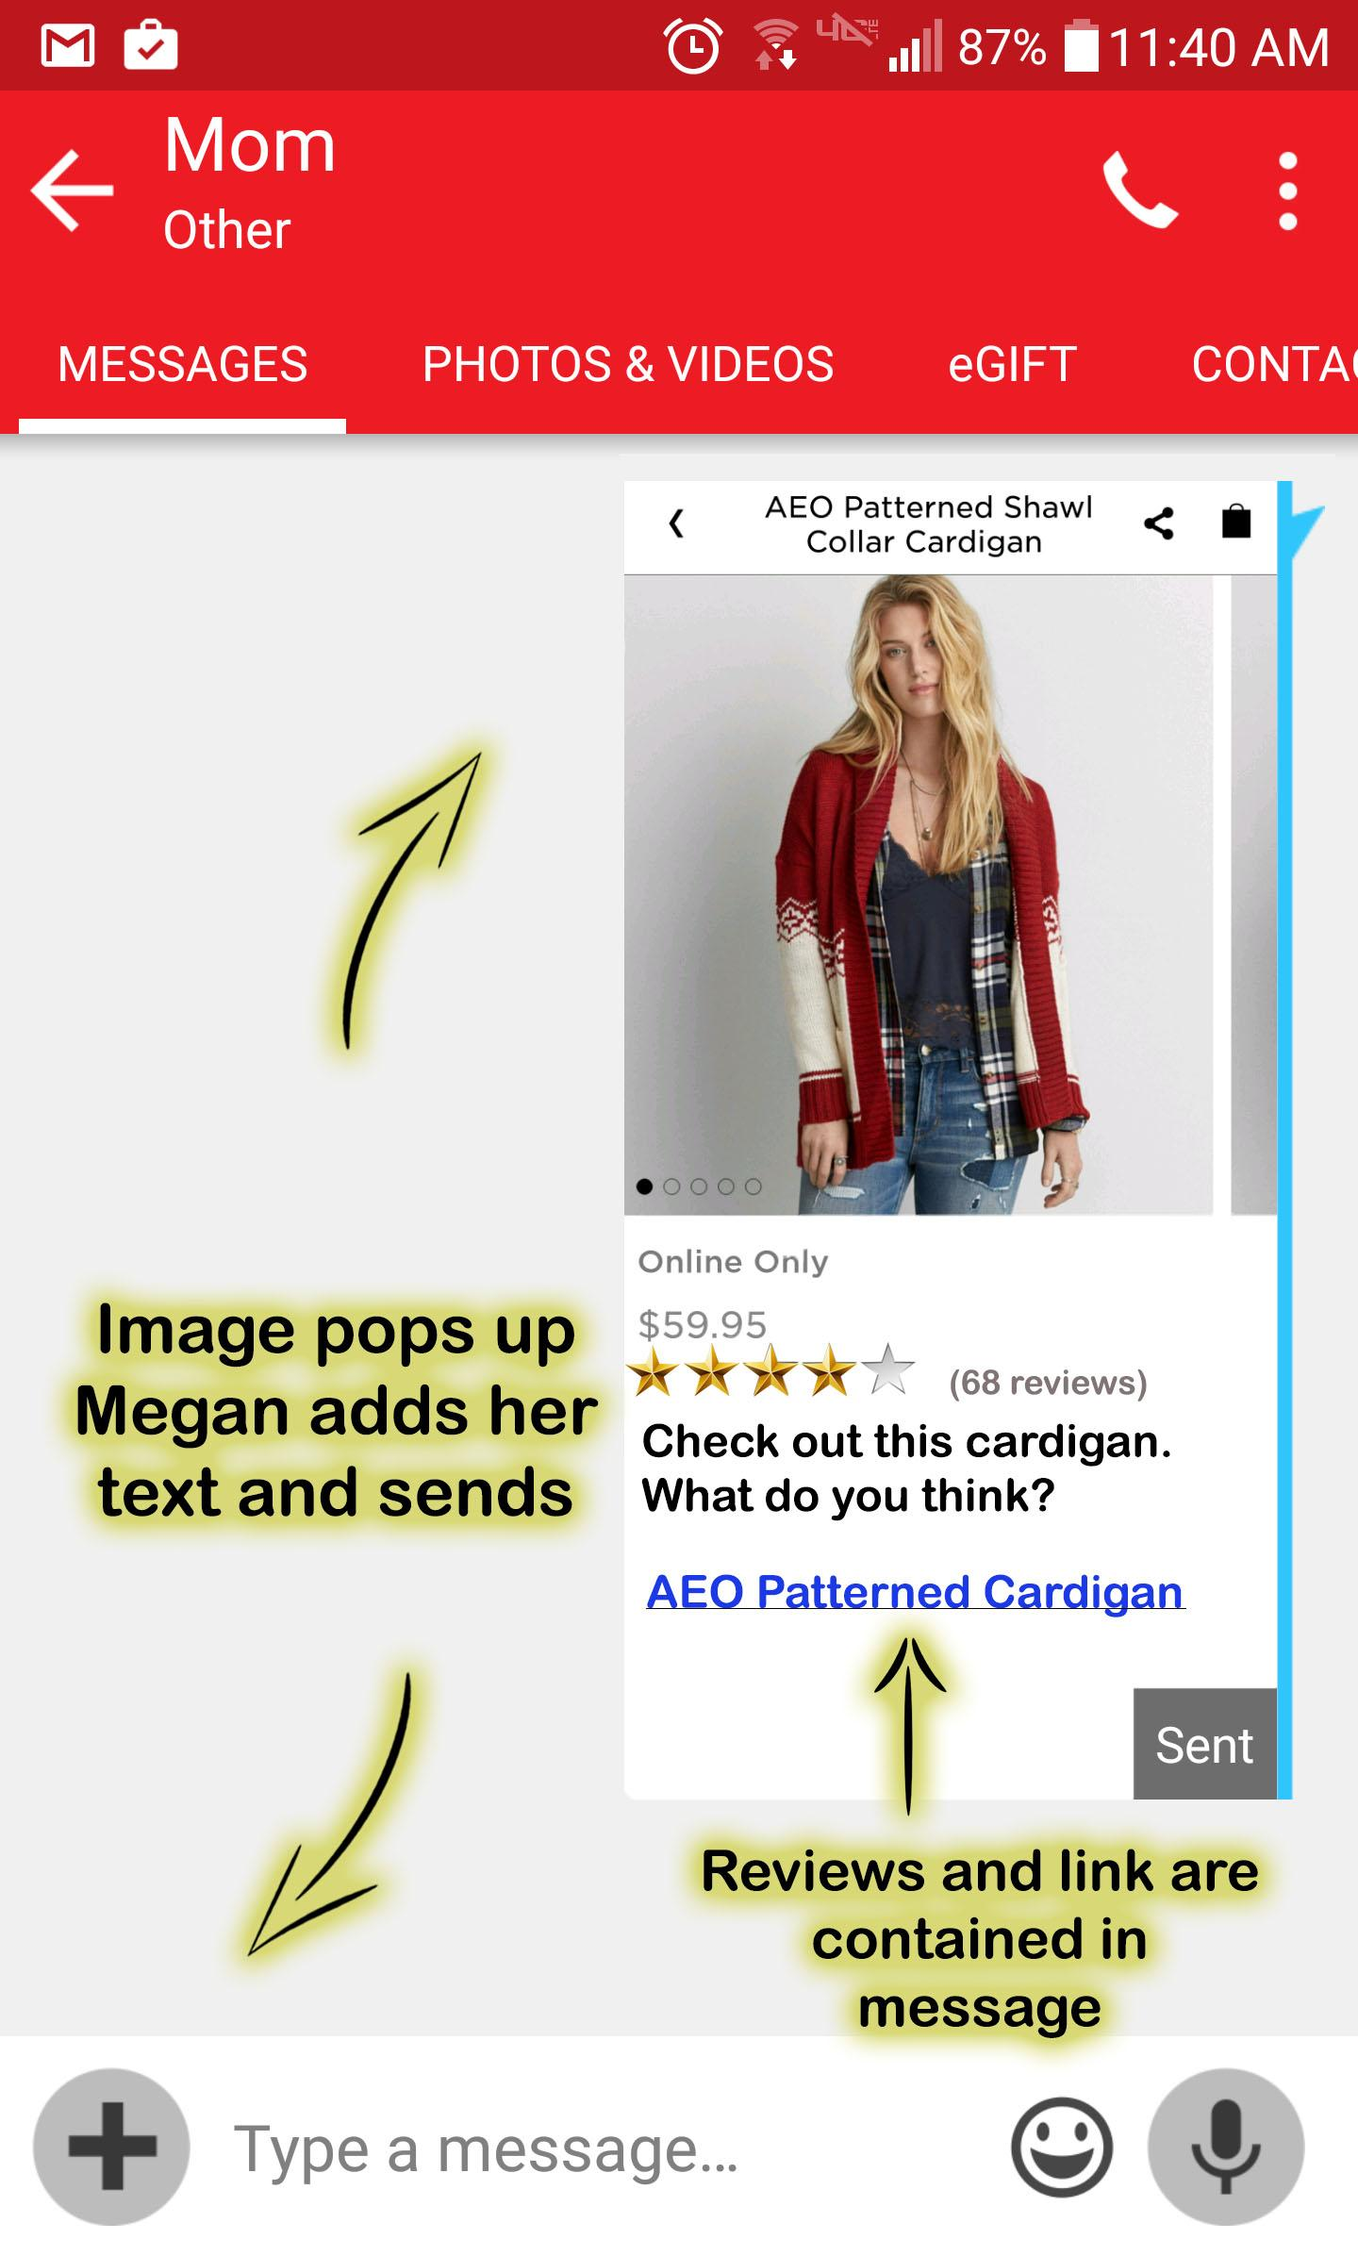

Other Visual Comps: The Rewards Program

Everybody loves a good deal, and thanks to Aidi’s subtle prompting, it’s easy to earn rewards for giving reviews on purchased products or sharing content on social media. This encourages users to share more, and the feedback generated allows Aidi to make better suggestions.

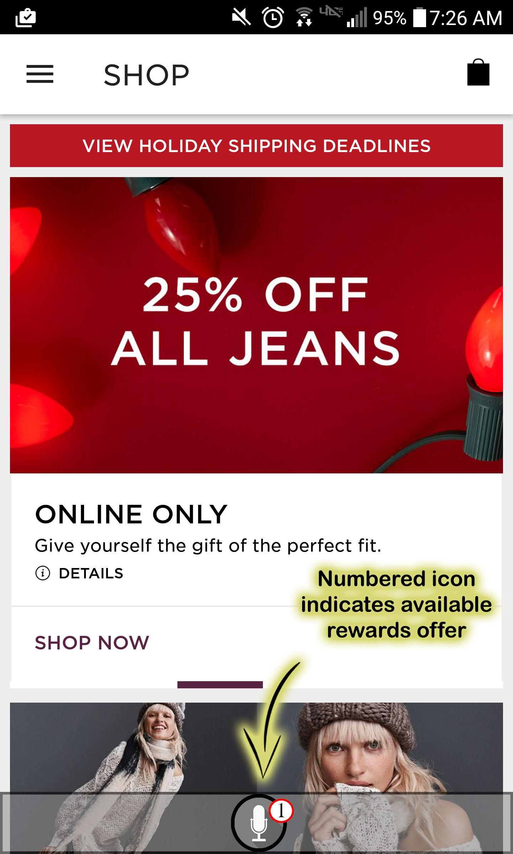 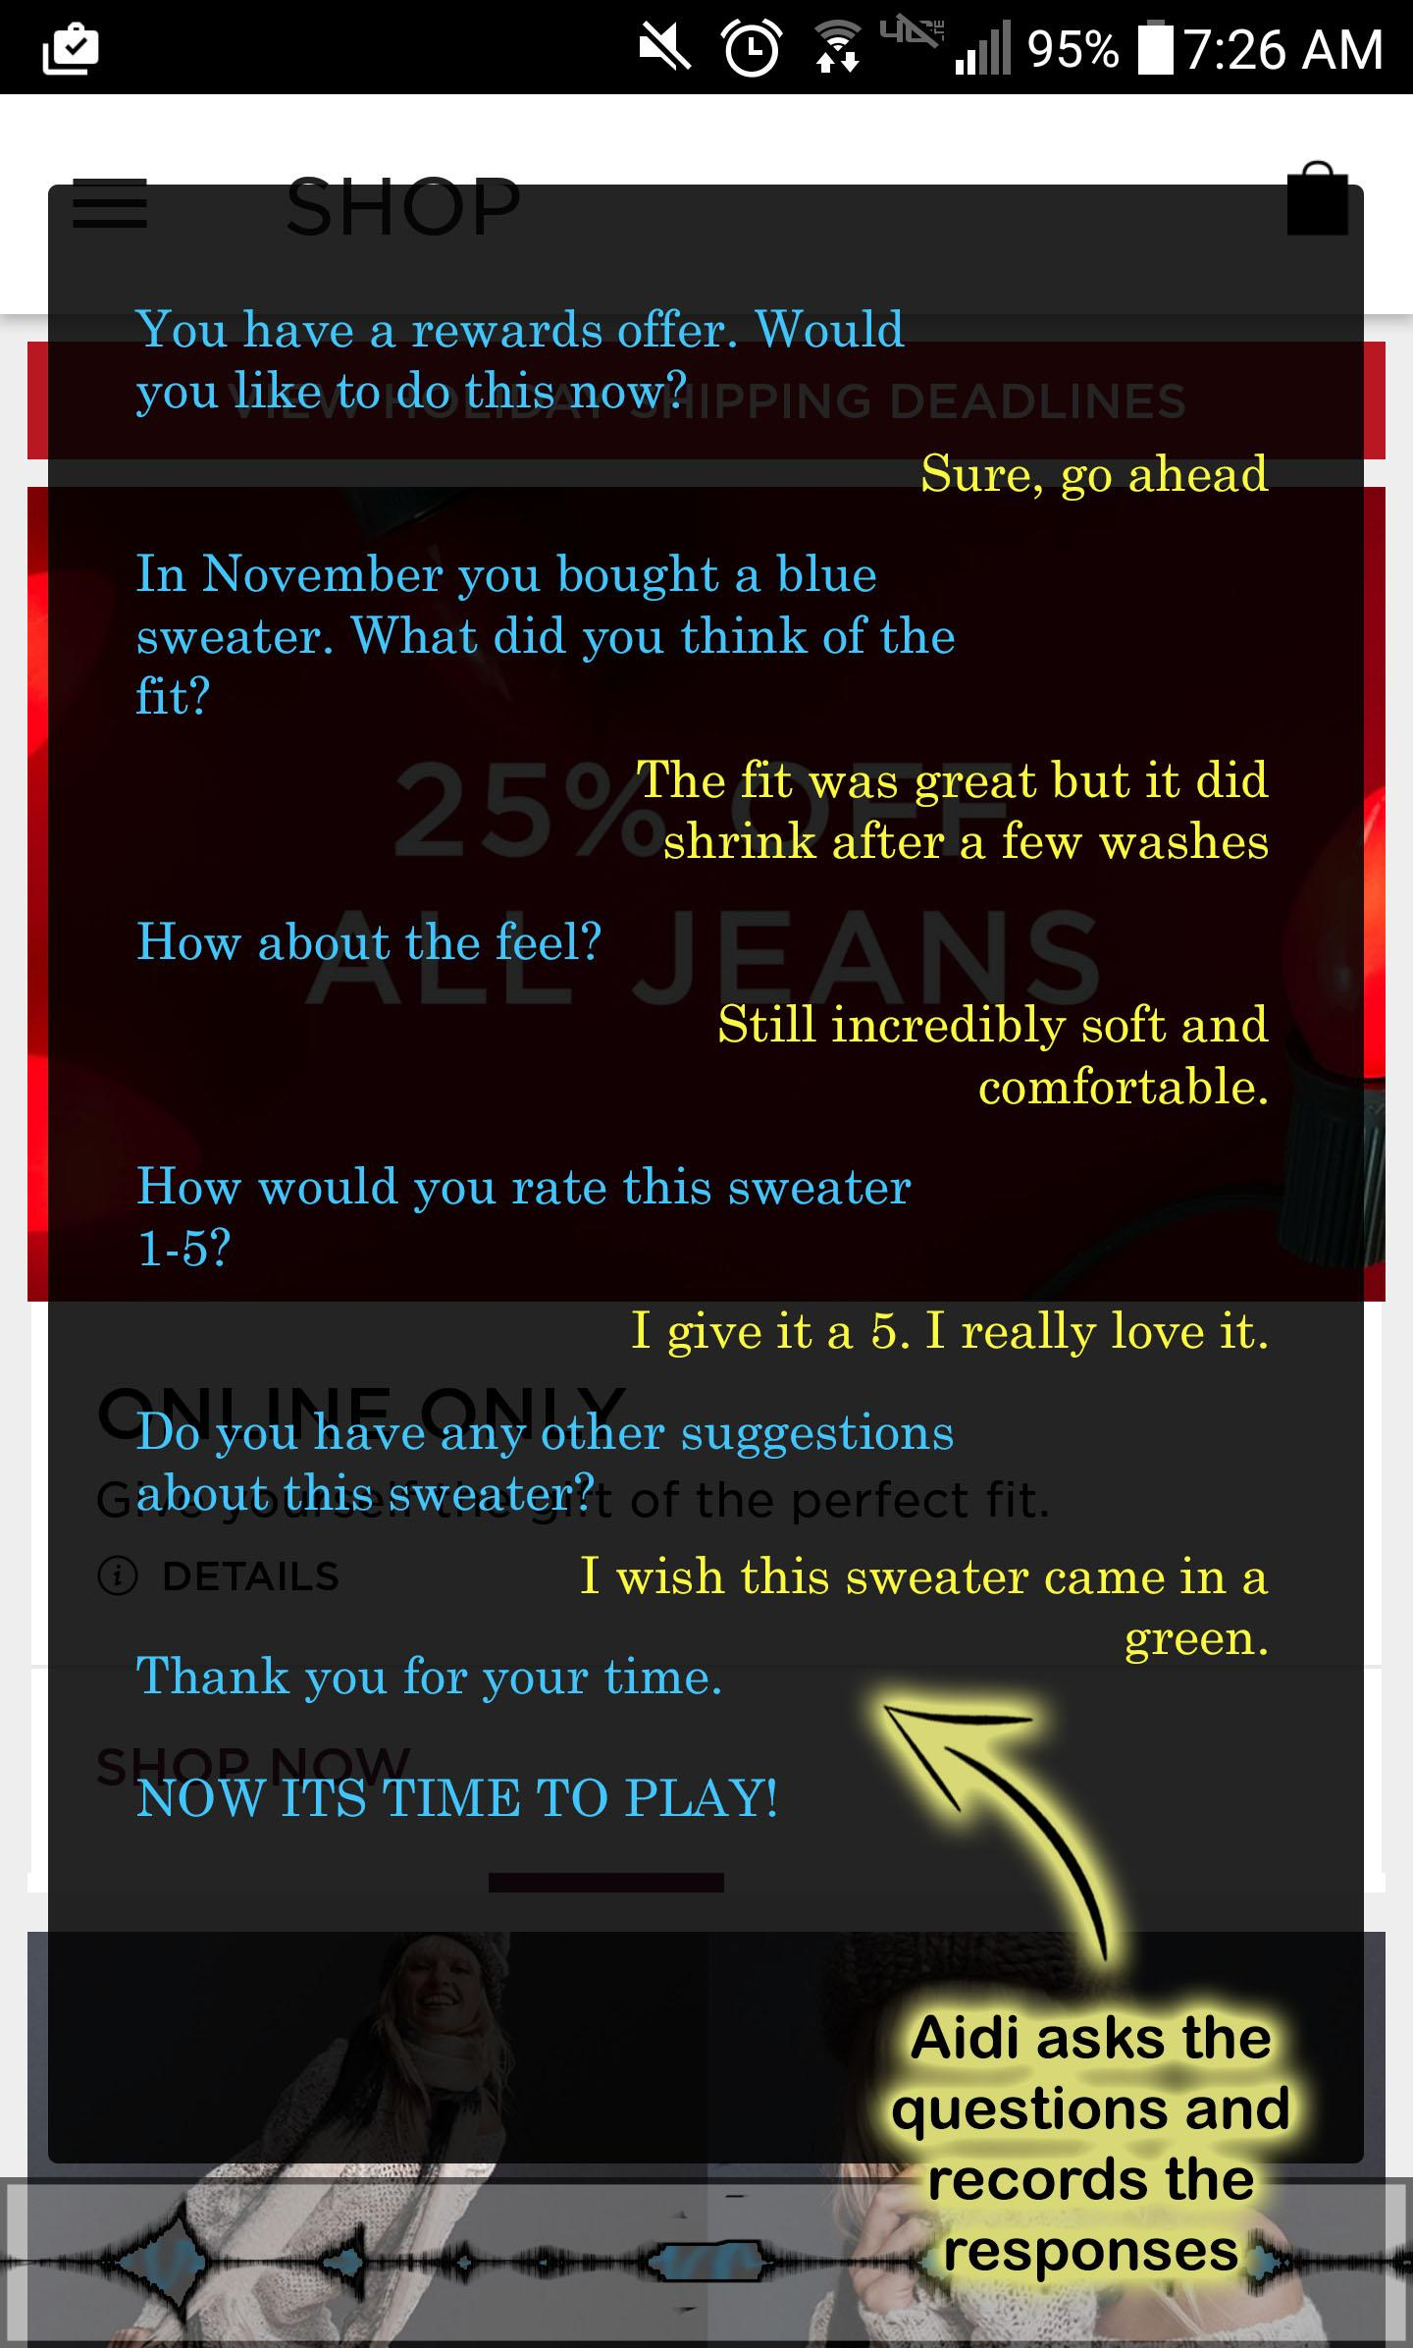

Rewarding users for reviews ensures that Aidi gets the feedback it needs and brings customers back to spend their bonuses. Once they’ve provided their feedback, Aidi takes them right back to their search.

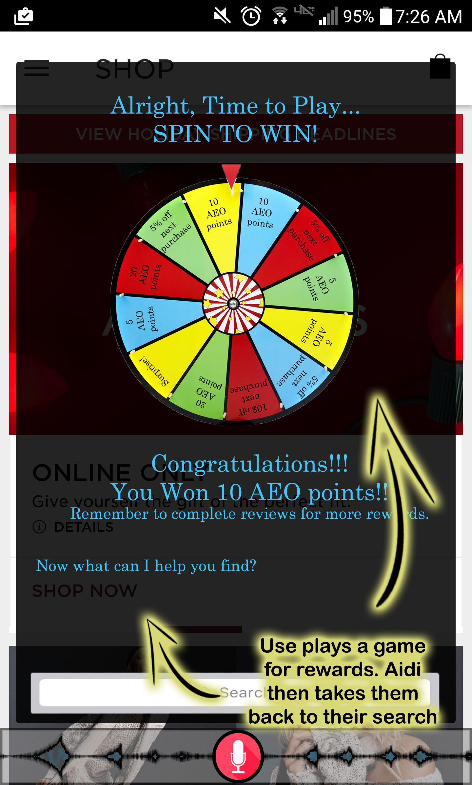

Major Benefits

* Increase product reviews
* Increase consumer confidence
* Reduced returns
* Increased online sales and visits

Final Recommendations

Although this technology is still in its preliminary stages, it has potential to increase user experience and improve data analytics. Being able to bring information straight to the user will change the way people get their information and interact with one another. Future possibilities include:

* + Body composites
    - With the ability to analyze, scan and 3D model users' bodies, along with access to users' social media accounts and photographs, the interface design team believes that creating body composites of users could help solve the problem of fit and feel in a virtual setting.
  + Meta-reviews: Virtual Suggestion Box
    - Users would be able to give suggestions as to what they would like to see (products, sizes, colors, styles, etc.). AEO would be able to organize and analyze those reviews in order to adapt their clothing line and products to tailor to what users want.