UTILIZING AE + AERIE APP: AN IN-STORE EXPERIENCE
  - https://g3aaf7.axshare.com/home.html

Daniel Priore
Jeffrey Stockman
Mary Smith
Sean Spencer
Duquesne University

Table of Contents

Executive Summary 3
Introduction and Problem Statement 4
Interview 5
Findings 6
Product Solution 7
App Design 8
Prototype User Testing 10
Conclusion 11
Appendices
- Task Scenarios 12
- Personas 13
- Wireframes 14
- Visual Comps 17

Executive Summary

American Eagle Outfitters presented students of Duquesne University with a plan to create an interface design that allows their customers to better their involvement in their shopping experience. Through interviewing processes, our team has conducted research that leads us to believe there is nothing to change in the voice recognition and augmented reality world other than where it is placed and how people are prompted to use it.
Our team has created a relationship between customer and associate through the use of mobile devices via profiles. These profiles will enhance the one-on-one experience while shopping in store, enable a more efficient check-out process, and allow the customer to have more knowledge about the products they are interested in while in store. All of this will be accomplished along with implementing voice recognition, that has already been placed in app, throughout the new processes.

Introduction and Problem Statement

People do not want something new, they want what they already have and for it to be achievable in a more efficient manner. When discussing voice recognition and augmented reality, we considered what the American Eagle App already had pertaining to the two. After seeing what the existing app had, we conducted an interview. We found an interview to return a more accurate understanding of how people feel towards VR and AR. We interviewed 20 people between the ages 20 and 30. Some of which had worked in retail in the past or were currently working and some had never worked in retail at all. Our interview consisted of six questions. We asked these specific questions to better understand how people are generally using VR as well as how they respond to AR. Given that AR has not yet reached a feasible range of use, we decided to elaborate on what we knew people were already comfortable using, which was VR.

Interview

- Are you familiar with Alexa, Cortana, or Siri? – Everyone knew about each of these, some utilize Alexa and Siri
- What uses do you have for them? - ~ most only used Siri for simple commands in order to avoid doing more steps to get a final result ~ where our main idea stemmed from
- Do you use the AEO app – are you a rewards member? Also- are you a member or have an app for any other clothing store – most interviewees are AEO rewards members
- Would you use VR through any shopping experience whether in store or online? – majority responded with no, a few said they would be willing to see how it works but most likely would not utilize it.
- What information about a costumer would help you on an associate side of things? / what information would be helpful for an associate to know when helping you with your shopping process? – all responded similarly; knowing more about the customer will ultimately help the shopping experience the most.
- What features would be helpful when shopping in store or online?

Findings

The answers to our interviews were geared heavily towards the idea that no one is incredibly impressed with either VR or AR. However, through this interview, we have found that people are always willing to try new technology. The main defining factor between whether new technology will be useful or not is finding out how to make new technology accomplish new goals without having to teach someone how to use it. When introducing new systems, it is easy to understand how much smoother the process could be if people knew how capable technology is becoming. The downfall of that; people are not willing to understand. Our generation is fixated on the idea that they want everything to be easily and readily understood. Yes, VR could do amazing things. However, people are not willing to cut out what they don’t find to be difficult in the first place.

EX: instead of using VR to send a recently taken picture, people will still go through the process of going to the message app and find the picture and then send - when they could have easily used VR to request that task being done.

The main use we found that people use is VR for simple commands. We found this response very useful in regard to the AEO app considering that the shopping process is filled with simple commands.

EX (for in store): “request fitting room for four clothing items”
EX (online): “women’s baggy ripped jeans”

Once we discovered that simple commands are used in the shopping process as well as the main use people find for VR is for simple commands, we decided to better combine the two. AEO already has voice recognition implemented in their app design. However, it is placed somewhere where not many people would feel the need to use it, the search bar. Our group wanted to find a way to connect the comfortability people have with using their phones while in store. Like we had mentioned in the interview responses, a few people had mentioned they would give a more elaborated use for VR a go.

Product Solution

With all the research and ideas generated, our group found that it would be useful for the AEO app to create a profile for their customers and sales associates. This profile will give the in-store customer to associate communication a more virtual feel. Utilizing this profile, associates will be able to see who they are working with, specific details that may help in the shopping process such as sizes and styles preferred. They will also be able to keep communication between the customer on a phone device and readily available for a more efficient shopping process.

The Design

All the aspects that we need to cover to implement this communication between customer and sales associate will be accomplished in four different designs:
- The customer profile
  - The app will have a tab under “my aeo” where they can edit their in-store profile.
  - This profile will consist of
    - Favorite color
    - Sizes
    - A bio
    - Preferred styles
- What the customer sees when they walk into a store
  - As a customer’s location is detected, they will receive a pop-up notification welcoming them to the store
  - When opened, they will be prompted to answer two questions upon arrival
    - Who are you shopping for
    - What are you shopping for
  - The customer can then officially check in which will then be seen on the associates profile.
  - There will be simple requests that can also be used such as requesting a fitting room and requesting an associate (assuming the initial associate to customer interaction has already been made).
  - Ability to scan items they want and generate a master bar code for a speedy check out
- The associate virtual name-tag
  - Have a bio and picture for the customer to see who will be working with them
  - Gets a notification when customer requests assistance or initial arrival check in
  - Can view all current and past customers and their activity
- Location sign in
  - If location services are not on in settings, the customer can manually check into store

Prototype User Testing

Users were presented with a prototype that took them through the process of checking in and requesting an associate. Users found that the app was easy to go through. However, had a hard time deciding what they would request for. If our team were to do a user test again, we would have the user go through the prototype during a shopping experience to see how often they would try to utilize what our app had to offer.
In regards to usability, users did not find any difficulties navigating through the application.

Conclusion

People already know how to shop and aren’t looking for anything to be fixed. Therefore, people are less willing to learn new technology that requires them to do anything out of the ordinary. Requesting help from and associate is something that everyone needs, if we are able to cut down an initial conversation to understand what the customer needs/wants and automatically give it to them, then we are using technology to create a more efficient shopping process.

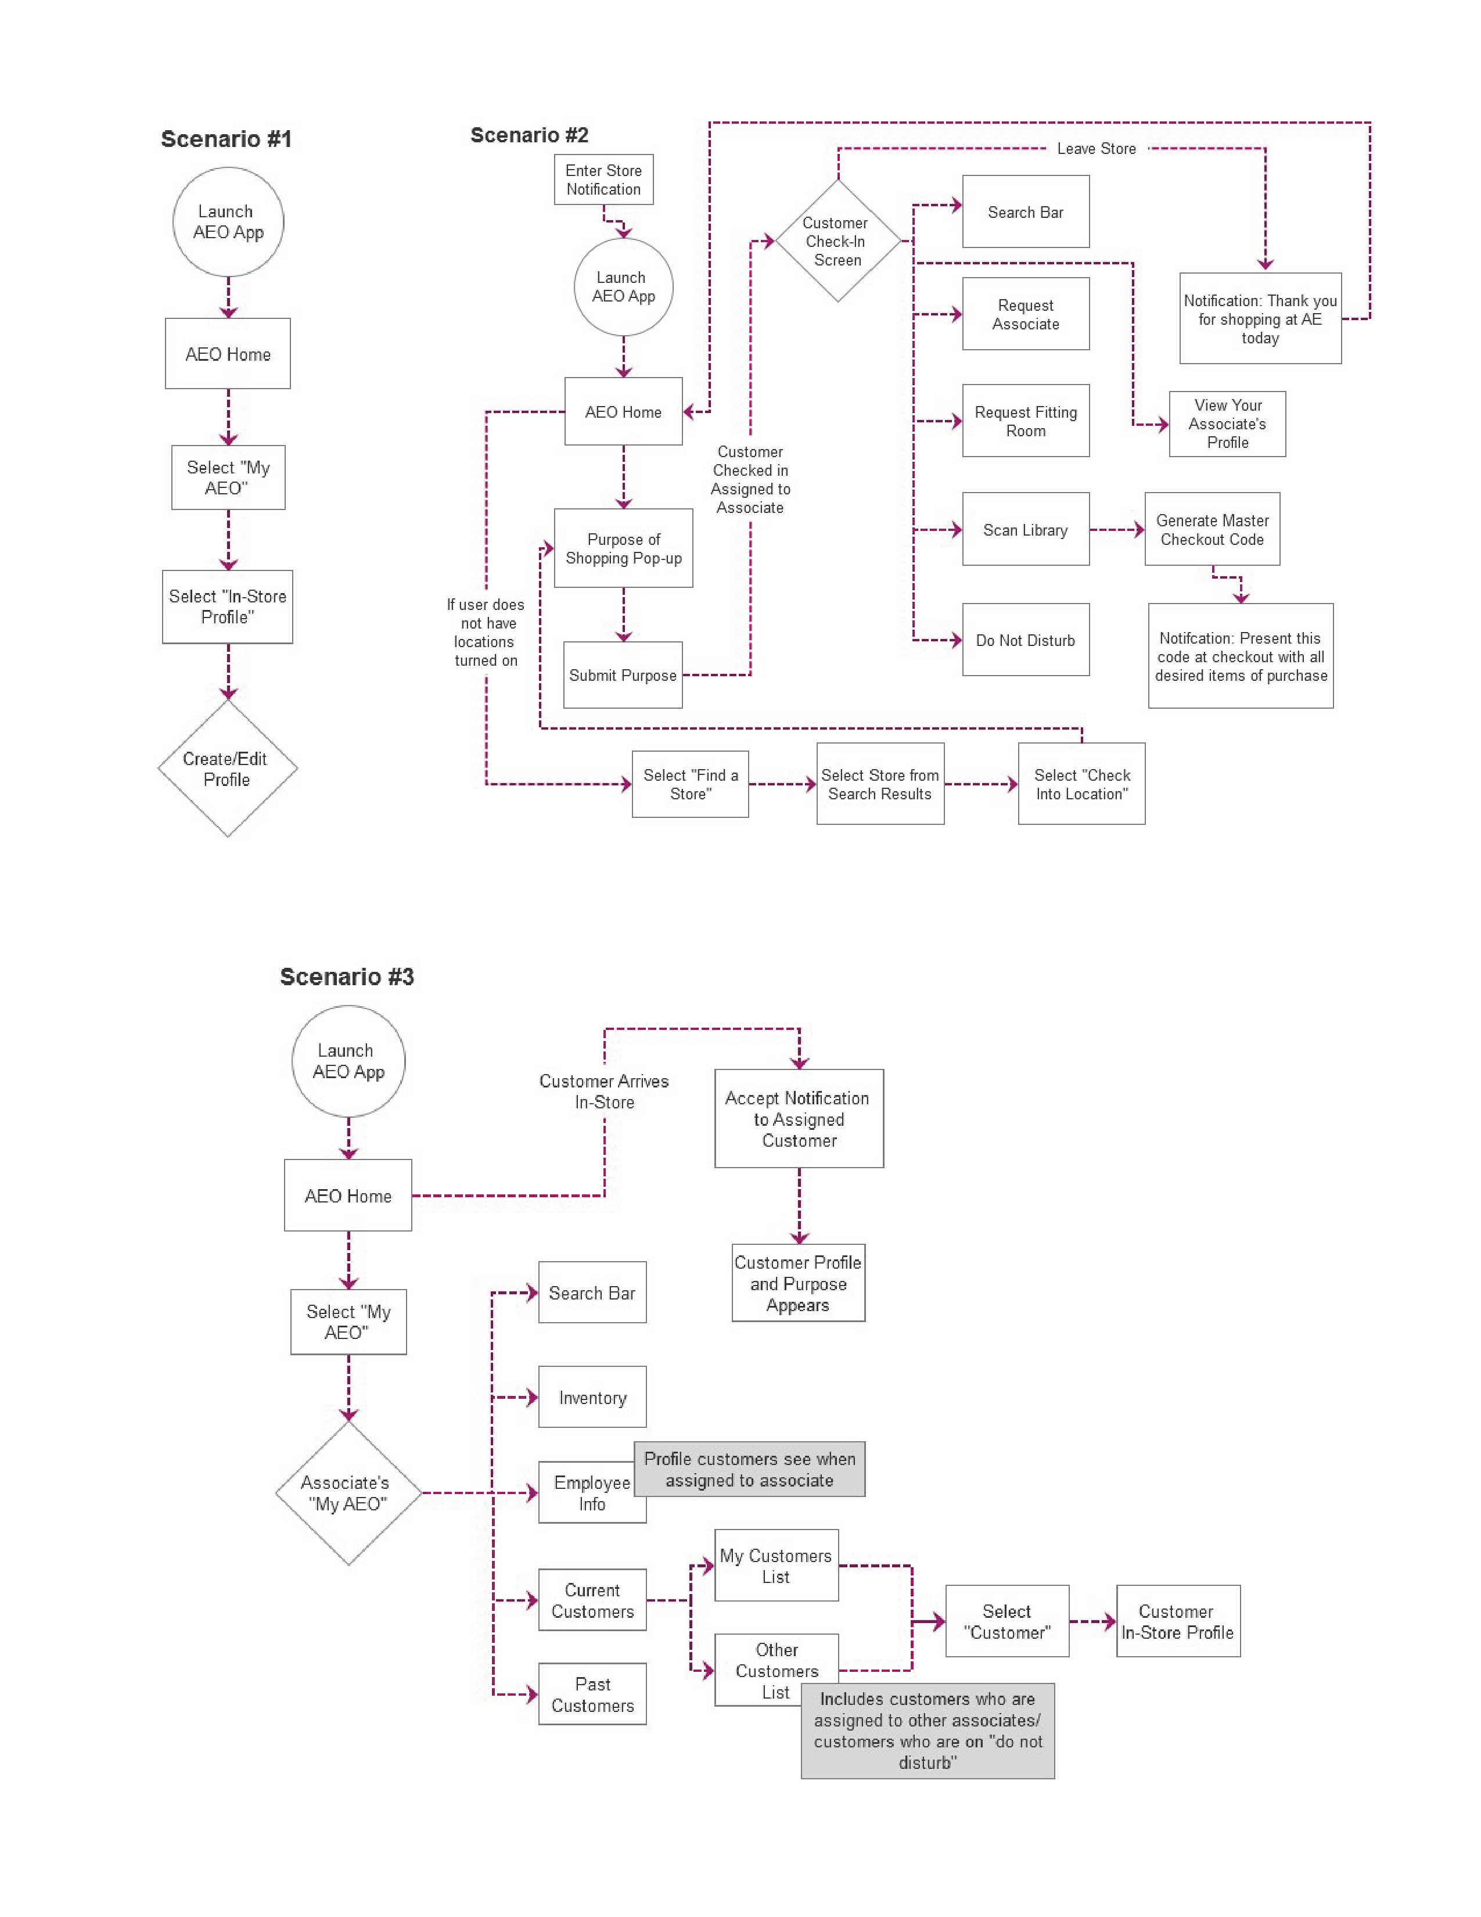
Personas

Alyssa is a 22-year-old college student who works in retail. She studies pharmacy and has very little time to socialize between her studies and work. She finds technology to work in her favor, as she utilizes phone applications to efficiently achieve tasks that would take too much time out of her day if she were to go out and accomplish these tasks outside of a virtual world. However, fulfilling tasks online does not always return accurate results. Therefore, she relies on technology to allow herself to accomplish goals without having to be bothered.

Kathy is a single mom of three. All of which whom are in high school. Although not into style, she attempts to always keep her kids pleased with the latest trends. Unable to stay up-to-date, Kathy relies on the one-on-one action between herself and sales associates to ensure she is staying on top of vastly changing trends. Although she relies heavily on sales associates to help her through a shopping trip, she believes no associate is able to fully understand her children’s style as well as keep them on a stylish track.

Patrick is a freshman in college studying political science. He is in the process of joining a fraternity where he is expected to always look his best. Patrick went to a high school in a rural area where style was not considered to be of high importance. He does not find it important to utilize much of his time to focus on what clothes he should be wearing. However, as a student who is striving for excellence and wishes to be a future politician, Patrick knows this is a priority he must make. Patrick is not looking for his own taste to show through the clothes he wears. He merely would like for someone to tell him what is appropriate for certain occasions.

Gabby is a recent college graduate who had studied to be a graphic designer. She has a spunky attitude and knows what she wants. Gabby can make anything look good when she finds her own unique way to bring different styles together. However, she thinks we live in a world where everyone looks the same and is trying to wear the same clothing. This provokes clothing stores to gear all their clothing to fit one specific style. Gabby is tired of seeing the same style over and over again. She likes AEO clothing material and quality but has a hard time seeing passed what is displayed. She prefers to find the diamond in the rough type clothing and doesn’t know how she would achieve finding all of these special pieces of clothing with shopping alone.

