Digital Makeup Exercise rev 11/3/2014

Objectives

* ***Blend Mode*** options
* Changing a layer’s opacity
* Using the ***Brush*** tool
* Using Gaussian blur
* Download and open ***makeup.jpg*** from the web site. It should look like this:

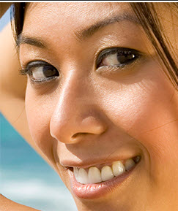

**STEP ONE:** Add a new layer

* Double-click on the ***Create a*** ***new layer*** icon

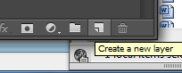,

* Name it ***lips***
* Double-click the new layer
* This should open:

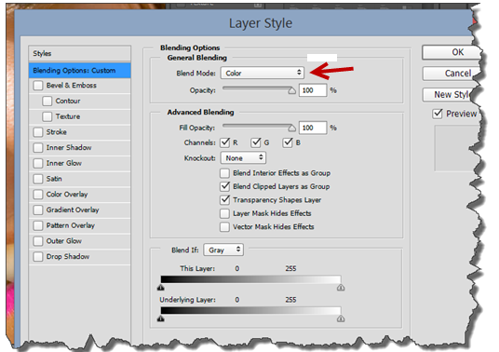

* Set ***Blend*** ***Mode*** to ***Color***. (See above)

This menu lets you change the way color on one layer blends with color on another layer. Using the ***Color*** mode keeps the brightness of the tones in your photo, but adds the hue and saturation values from the paint you’re about to apply, letting the details of the image show through.

* Click OK, and make sure the ***lips*** layer is above the photo layer in your layer stack
* Rename ***Background*** as ***model***.

**STEP TWO:** Press B to activate the Brush tool

* Or select it in the tool box:

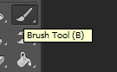

* Click here to specify a size and hardness

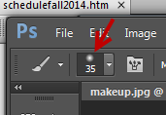

* Pick a soft-edged brush.

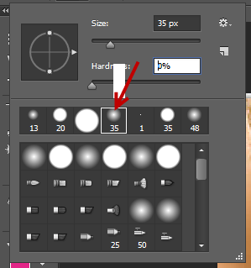

* Change the ***brush size*** to about 10 px

**STEP THREE:** Click the ***Foreground*** color swatch. In the resulting ***Color Picker***, enter CMYK values you see below:

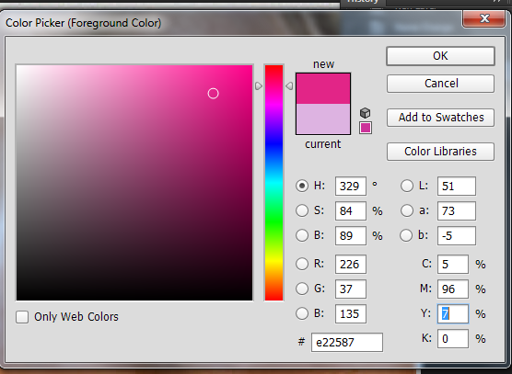

* Zoom in
* **STEP FOUR:** Paint across the lips.
* Select the ***lips*** Layer
* Use a larger brush for the inside of the lips and a smaller one for the edges.
* Use “ [ “ and “]” to change brush size

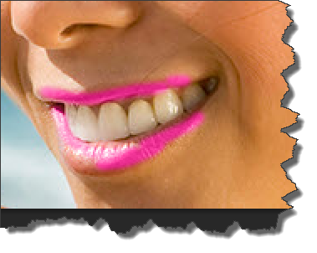

ISTOCKPHOTO, JACOMSTEPHENS, IMAGE #3391020

**STEP five:** With the ***lips*** layer active, choose ***Filter>Blur>Gaussian Blur***. In the resulting dialog, experiment with the ***Radius*** to produce a very soft blur

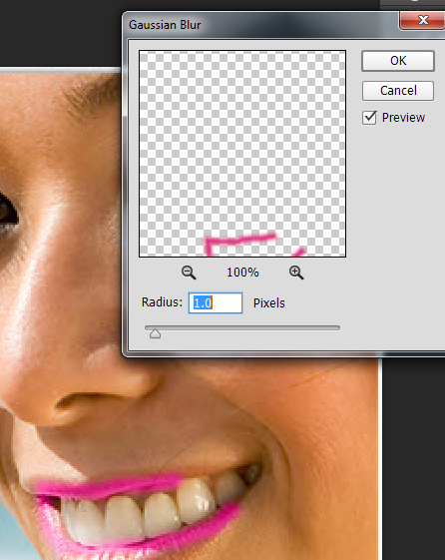

This helps the new lipstick blend in with surrounding pixels. If necessary, use the ***Eraser*** tool to fix areas of paint that have blurred beyond the lip edges.

**STEP six:** Reduce the ***Opacity*** of the lips layer in the ***Layers*** panel to your liking (about 30% was used here).

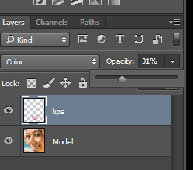

Result:

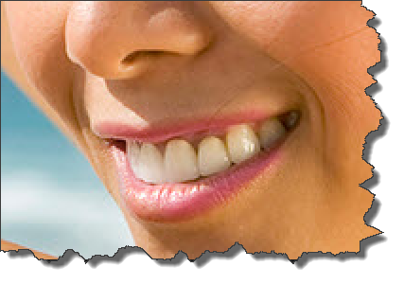

**STEP Sevin:** Repeat Steps to add eyeshadow, blush, etc. If adding multiple colors of eyeshadow—say, one for lower lids, one for upper lids, and one for the outer lid edges—be sure to add each color on a separate layer for maximum editing flexibility.

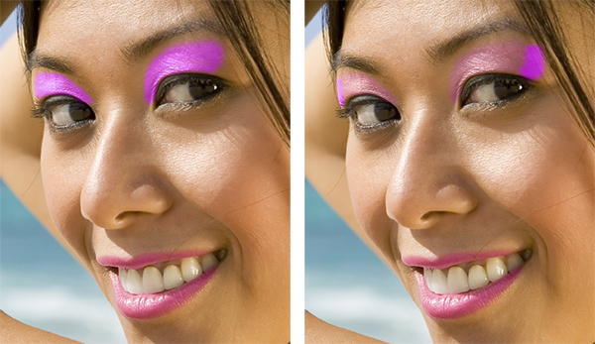

**STEP EIGHT:** To change the color on any layer, Use ***Adjustment*** layers, and choose hue/ saturation/lightness adjustments

* Add the eye shadow and blush: use the blend and opacity values from before

Use your own colors

* Save as makeup.psd
* Save as ***makeup.jpg***.
* Save both in ***PhotoshopExercises*** folder

END

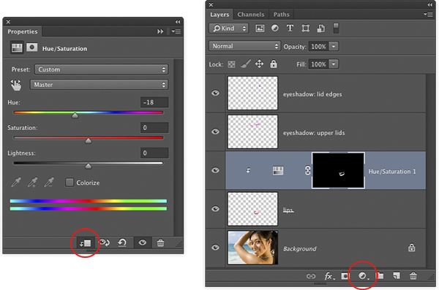

**STEP TEN:** Choose File>Save As and save the document as a PSD file. Saving the document in PSD format lets you go back and edit the individual layers later. Here’s the before and after version of the image, along with the final Layers panel.



