* + [Articles](http://www.lynda.com/articles)
  + [Authors](http://www.lynda.com/Home/Authors.aspx)
  + [Documentaries](http://www.lynda.com/Documentaries-training-tutorials/1459-0.html)
  + [Playlists](http://www.lynda.com/PlaylistCenter)
  + [Software](http://www.lynda.com/software/all)

**Welcome**

- Hi and welcome to a Lynda.com training class “”Adobe Camera Raw Essential Training”.. As Photoshop has evolved, it has developed into three distinct applications. ***Adobe Bridge*** which helps organize and manage our photographs, video, audio, and more. ***Adobe Camera Raw*** for image enhancement, automation, and the creative processing of photographs, and Adobe Photoshop for the ultimate in photo manipulation, compositing and retouching.

* Borrow a camera and shoot outside using a setting that captures jpg and RAW. Take 15 minutes, then return.
* Download from our site the two images of a lighthouse. Save in Photoshop folder:

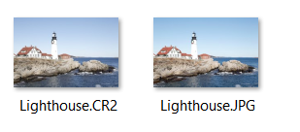

* Add two or more of your pictures as well.

**Opening files into Camera Raw**

- When people start using Photoshop and Camera Raw to open their files, they typically go to the ***File*** menu, and then select Open, which takes them to the operating system. And well, you can certainly navigate here and take a look at different images, many find it much easier to use ***Adobe Bridge***.

# Launch Bridge

* Navigate to your Photoshop folder. You should see:

You should also see your photos

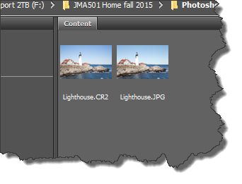

* Select the lighthouses
* Right-click and Choose ***Open in Camera Raw***

Here is what you should see:

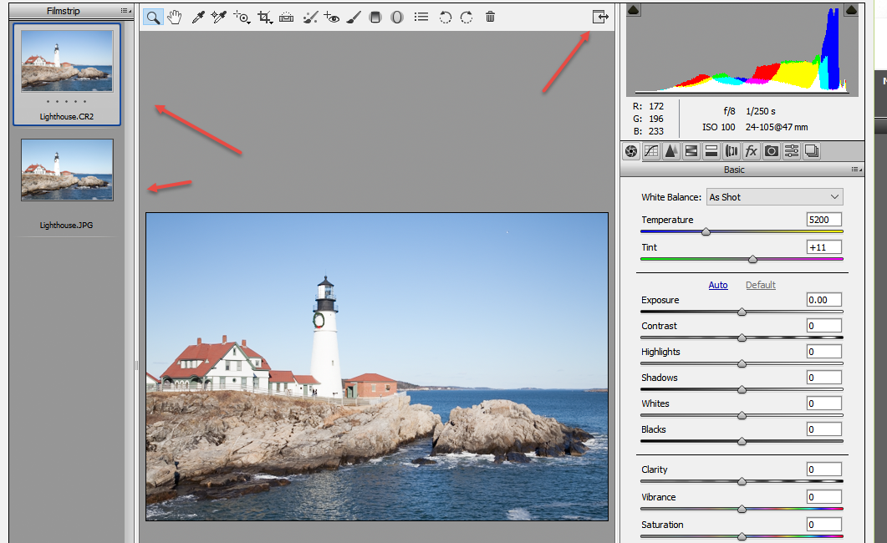

* Do the same with your pictures. If necessary, read from the SD card, save in Bridge.

There are a number of reasons that you should use CAMERA RAW to process your files before going into Photoshop and editing them.

The first reason is that everything you do in CAMERA RAW is Nondestructive. It has a completely flexible editing environment. And this means that you can make as many changes that you want to an image, but at any point in time, you can alter those changes, or you can remove them altogether.

The second advantage is that CAMERA RAW has a built-in workflow.

The features that are offered in the sliders and the panels, they're structured, and you can follow them, which takes the guesswork out of what you're supposed to do. Sometimes it's really hard, when you open a file in Photoshop, to know if you're supposed to use a menu, or a tool, or work with the Layers panel. So working through ADOBE CAMERA RAW, it really simplifies what you need to do first to your images, in order to optimize them.

Another advantage is that CAMERA RAW Supports not only RAW files, but also JPEG files, and TIFF files. So, once you learn all of the different options in the CAMERA RAW dialogue, you can quickly apply them to all of these different file formats. CAMERA RAW can also be automated. It's really easy to apply changes to hundreds of photos at a time.

Finally, CAMERA RAW has a very simple learning curve. While Photoshop has Layers and Masks and Selections, and Adjustment Layers, and is truly, truly powerful, the benefit of using CAMERA RAW is that you can get up-to-speed very quickly, and you can master all of the tools. So now that we know the advantage of using CAMERA RAW, it's time to see the workflow in action.

***Comparing raw and JPEG files***

- There are two primary formats that digital cameras can capture today. They're RAW and JPEG. But what can be confusing is that there are a lot of different flavors of RAW. It's sort of a generic term that people use to describe the unprocessed data that the camera captures.

For example, Nikon's RAW file format is .nef and Canon's RAW file format is .crw. Now, these RAW file formats are all very similar and that they contain much of the same information such as metadata about the camera settings and image information but there's no standard way of writing a RAW file so each one has its own unique order to the data.

There is ***one RAW file format that's not proprietary and that's the DNG*** file format. And many people convert their RAW files to DNG because of the fact that it is an openly documented file format and they do this in hopes that their files will be open far into the future if they're not kept in a proprietary format. Adobe is the creator of the DNG file format and more information can be found on their website. But it's important to know that if you compare the quality of a RAW file versus a JPEG file, there's much more information in that RAW file.

Important: Capturing in a RAW file format creates images with greater dynamic range, a larger color space (Gamut) , and therefore, allows more flexibility in post-processing.

You can make larger adjustments to your RAW files without losing image quality. If you capture in the JPEG file format, while it does render a smaller file that's faster to download, it forces the camera software to process the file and while doing so, it's using lossy compression, which ***throws away thousands of colors and tonal values.*** The end result is that you can't make as dramatic changes to your JPEG files without losing quality. So basically, capturing in RAW gives you a bigger box of crayons to work with.

Let's take a look at an example. There are two images of the same scene, one jpg, one RAW and I'm going to click on the thumbnail for the ***Lighthouse.JPG.***

I'll go ahead and use the **zoom options at the bottom and I'm going to zoom into 200%. T**hen I'll hold down the Spacebar and that will allow me to navigate over here to the brighter area of the lighthouse. Now obviously, both of these images were overexposed but I'm going to use the Exposure slider here on the right-hand side at the Basic panel and I'm really going to bring down the Exposure quite a bit but you'll notice that no matter how far down I bring the Exposure, there's actually no detail in this highlight area of the lighthouse.

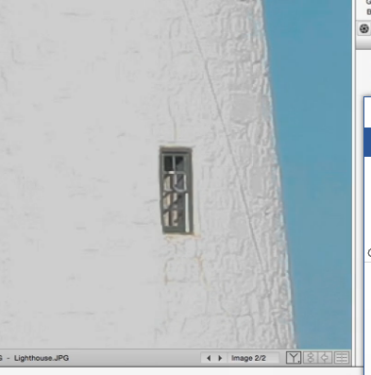

Let's go ahead and click on the ***Lighthouse.CR2*** file. This is the RAW file. Use the option at the bottom to zoom in to 200%, hold down the Spacebar. That temporarily gives me the Hand tool so that I can scoot over to view that same area and this time, when I move the Exposure slider in the Basic panel down to the left, you can see that I'm actually able to recover detail in those highlight areas of the image.

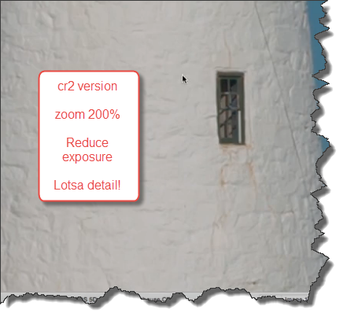

Apply the same procedure for ***your*** CR2, and jpg files…did you see a difference between the two?

Now, this isn't to say that you shouldn't do your best to make the correct Exposure in camera. It's just to point out that if you do need to make changes to your image after the fact, you have more information to work with if you capture that image in RAW. Of course if you really overexpose your image, then even capturing in RAW might not save you. If there's no information in the highlights, nothing can bring back something that's not there. All right, for now, I simply want to cancel out of this dialog box. I don't want these changes to be applied, so I'll click ***Cancel***.

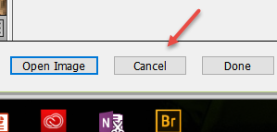

Then click Yes and return to Bridge

There are times when capturing JPEGs has its distinct advantages. First of all, the files are gonna be much smaller and they're faster to download, therefore, some experienced photographers, like an event photographer, for example, that is photographing each participant at an event with the same background in a controlled lighting condition, if they're confident that their images will not need corrections, they might definitely wanna capture as JPEG files but for most of us, I would recommend that if given the option, capture in RAW so that you have the ability to make corrections and post without compromising the image quality.

**Touring the Camera Raw user interface**

* Open and save the water.dng image:

We need to familiarize ourselves with the Camera Raw interface. So with the Water image selected, click on the Opening Camera Raw dialogue. Now, I've already gone to Full Screen mode, but if you haven't, it's this icon right here

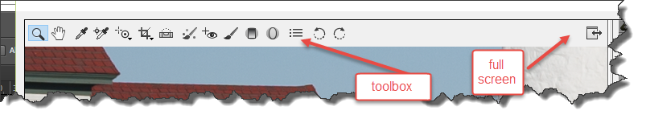

Go ahead and toggle between the dialogue box just coming up in the center and taking up the entire monitor (full screen) . On the upper left hand corner, you'll notice that we have all of our different tool.s (Look above)

We have a tool to Zoom in, we've got our Hand tool that pans around, we also have an ***Eyedropper*** tool, we have our ***Color Sampler*** tool, and our ***Targeted Adjustment Tool***.

You'll notice that if you hover your cursor on top of the tool, it gives you a tool tip, as well as the keyboard shortcut for the tool in parenthesis. So the T key would automatically select that ***Targeted Adjustment Tool*** for us. Some of the tools also have these little triangles

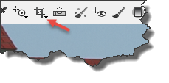

. If you click and hold on the tool, you actually get additional options for that tool. So we have a Crop tool and our Straighten tool. We also have our Spot Removal tool, our Remove Red-Eye, and then we have some localized adjustment tools, including a Brush, a Graduated Filter and a Radial Filter.

We could also quickly take a look at the Camera Raw Preferences by clicking here

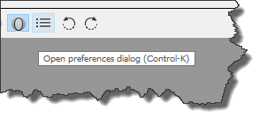

For now, we'll just click Cancel. And we can rotate our image using these last two icons. In the center, we have our Preview area, and in the lower left, we have all of our different Zoom options. We can simply click on the minus or the plus icon here, or we can move to a specific zoom level using the popup menu right here. There's some great keyboard shortcuts, however, for zooming.

If I use cmd + plus and minus on mac or ctrl + plus and minus on Windows, this will allow me to zoom in or zoom out of my image. If I use opt + cmd + 0 or alt + ctrl + 0 that will take me quickly to 100%. And if I just want to see the entire image, if I want to go quickly to ***Fit in View***, that's just cmd + 0 or ctrl + 0. I have additional controls on the right.

I've got my Histogram

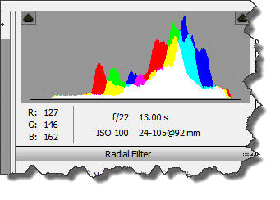

as well as ***Clipping Warnings*** in the upper left and upper right.

I have a number of different camera settings here, and I have all of my different panels. So for example, in the ***Basic*** panel,:

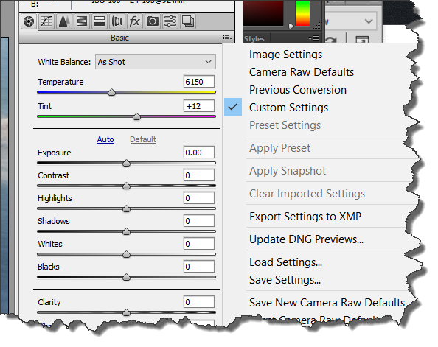

we can change our White Balance or we could change our Exposure. I could even do something as simple as adding Vibrance to this image. Of course, there are many other panels. We've got our Tone Curve panel. We've got our Details panel, HSL and Grayscale for making color conversions or desaturating selective color ranges.

We can add color tints with ***Split Toning***. We can make ***Lens Corrections*** as well as ***Perspective Correction***, plus add special effects here, including Dehaze, Grain and Post-Crop Vignetting. There are also some Camera Calibration options. We can create and save presets, which would appear here, as well as Snapshots. Right now, I'll return back to the ***Basic*** panel. And, let's move back over to the lower left . If I was done making changes to my image and I just wanted to save out a jpeg, I could use the ***Save Image*** option without having to take my photo to Photoshop to edit it.

In the center, we have a hyperlink and if we click on this, this is how we determine what colorspace (gamut) as well as file size we're going to take into Photoshop when we click on the Open Image right here. If for some reason, we didn't want to save these changes, we could click Cancel. But for right now, let's go ahead and just click ***Done***.

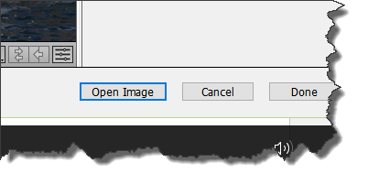

And we can see that that takes us back to Bridge/Photoshop with that change applied. And in fact, we'll notice that on the upper right of the thumbnail in Bridge, I know that this image now has changes applied by Camera Raw by a little icon you should see:.

So there you go, a quick tour of the Camera Raw interface