**Animation” of stills: Zooming/Panning rev 04/13/2016**

**Open your latest project**

## Zooming Animations

We will make an image start small; gets larger as we zoom in

* Select any clip
  + Move the play head over the clip
* Right-click and choose ***Remove Effects:***

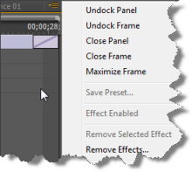

* Click OK:

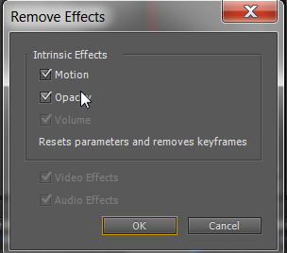

Your clip should now be back to its original size

* Click on the clip
* Open ***Effect Controls*** window (***Window>Effect Controls)***
* Move the play head to the start of the clip, on the ***Effect Controls*** window:

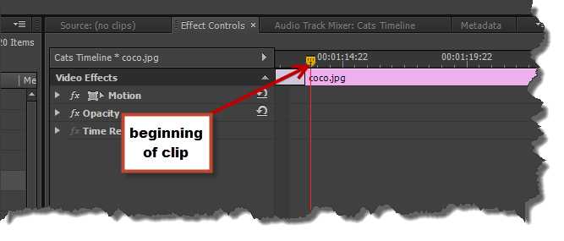

…we will use built-in ***Motion>Scaling*** effect…Expand ***Motion***

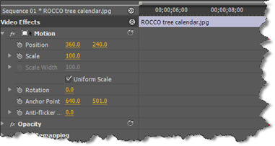

See ***Position*** and ***Scale***?

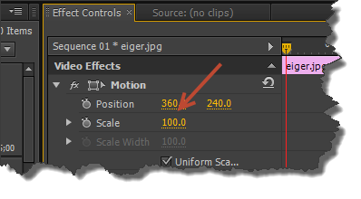

We’re going to “animate” the scaling. Adjust the ***Scale*** value so the complete image is visible. Mine was about 51%

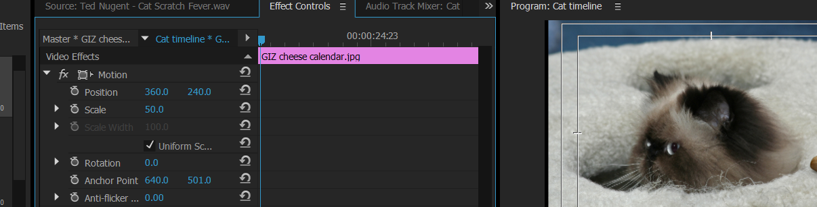

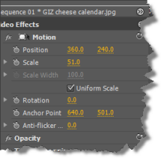

Result:

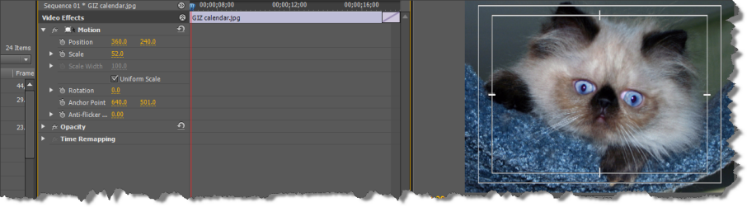

* Click the ***Toggle animation*** next to ***Scale***. (Personally I think it looks like an alarm clock! )

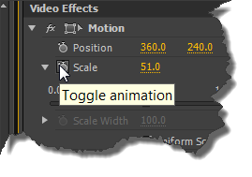

* This says to create an animation by having Premiere create new, in-between (***tween***), frames.
* This will add a starting keyframe---look for the small circle

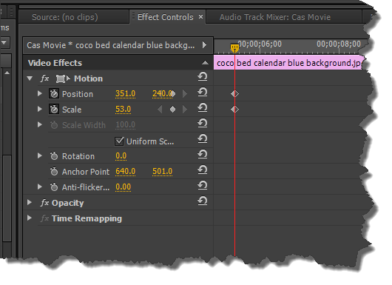

* Move to the end of the clip..***use the effects control playhead***

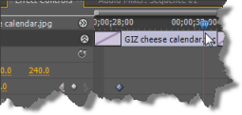

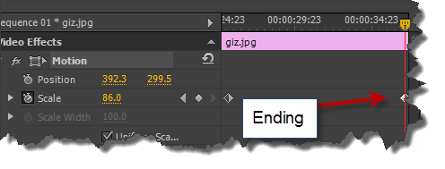

* Set the ***Scale*** to about 86% (Zooming in)

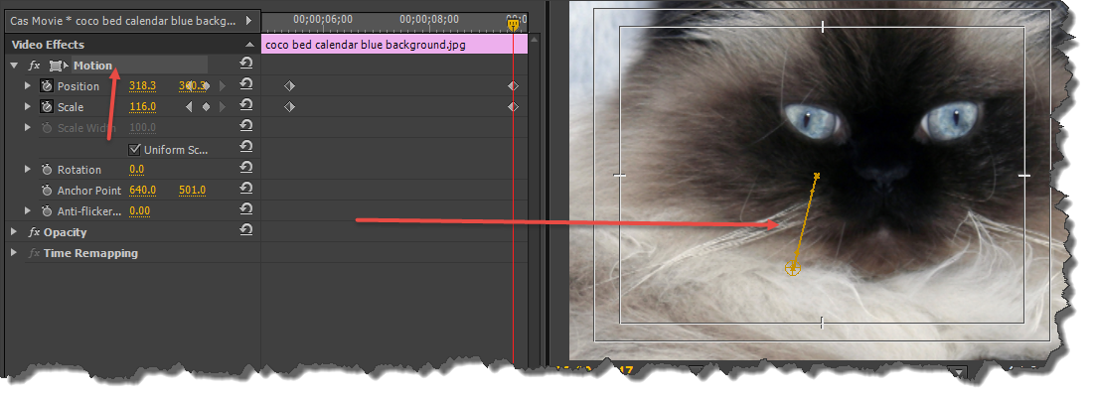

* An ending keyframe is automatically added, as you can see from above
* :

***Panning Animations***

* This time, we’ll pan ***across*** an image
* The result makes it appear to actually move the camera as we pan from right to left (actually any direction) .

Choose a clip and delete its effects so its size and location are back to original values.

* Click the ***Effect Control> Motion*** tab

Let’s start by positioning the image to the right, Only ***change the x-value*** so it will like motion moving from right to left

To specify a starting position, to the right:

* Click ***Motion*** button.

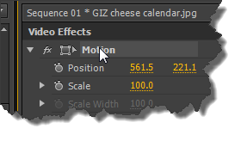

* In Source window, move the cat to the desired start position.
* Once satisfied, click the ***Toggle animation*** tool next to ***position***:

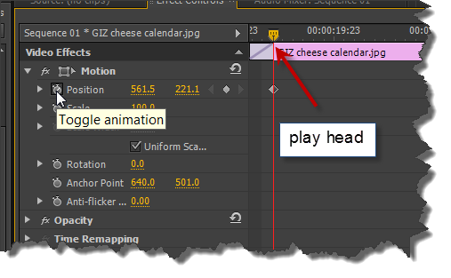

* Move the ***Effect Control*** playhead to the end of the clip
* Drag the image to its desired ending location:

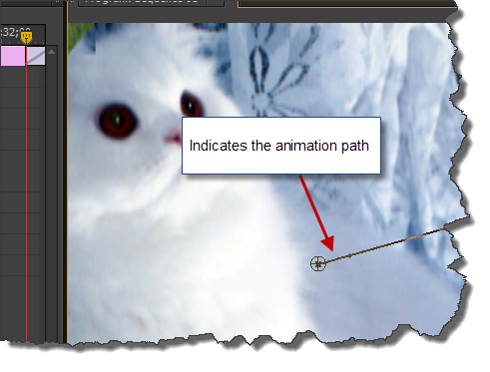

* Press ***Play*** tool on Program window

* Save as ***VideoAnimated***

***END***