Photoshop filters.doc rev 10/30/2015

Filters, fixing old Photographs

Download and open in Photoshop::
- Giz.jpg
- Old Image.jpg
- Tree

Sharpening (portion of) a picture
- Switch to Giz.jpg
- Let’s sharpen the area around the cat’s mouth
- Create new layer from the Background, name it Gizmo (Recall other ways to rename Background?)
- Select his face using your favorite tool…I used lasso
- Feather by 5 pixels
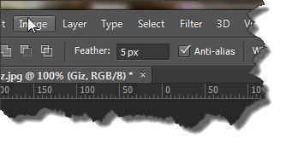
Or Select>Modify>Feather
- Choose Filter>Sharpen>Unsharp mask
- Use these values: Amount: 80%, Radius: 1.0, Threshold: 10
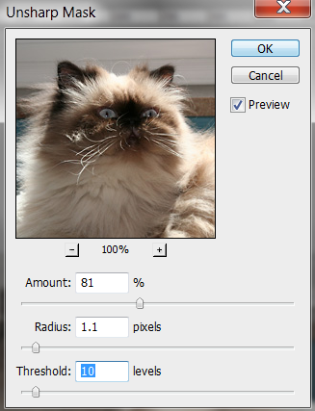

Rules of thumb: 75-100 for Amount (less for people, more for objects), 1 for Radius and 10 for Threshold
- Save as CatSharpened.psd

Questions?

Other filters
Switch to tree_before.jpg

Open Photo filters in the adjustment panel

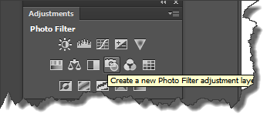
You should see:

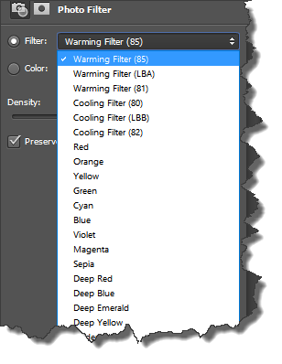
Most of these are carry-overs from film era. Filters were screw-on glass.
- Experiment…try filter 82
Too blue---reduce Density
- Try a few others

- Close

Filters: Fixing old photographs
- Remove scratches using a noise filter
- Sharpen
- Healing Brush
- Spot Healing Brush
- Here is the picture we will edit:
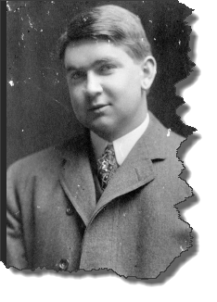

- Open/switch to Old Image.jpg
- Let’s delete some of the dust and scratches
  - Filter>Noise>Dust and Scratches

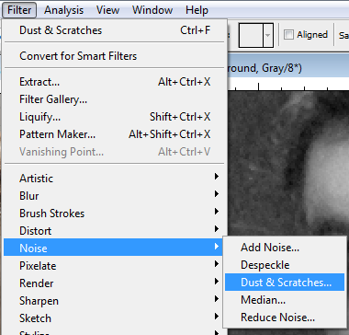

- Adjust the Radius and Threshold properties (be sure Preview is checked)
- Here are my values:

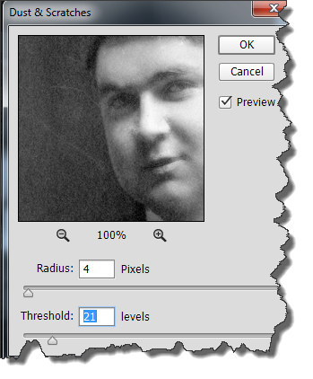
You can move the image around, zoom in/out
Let’s see if the Spot Healing Brush can do any better.
Choose File>Revert to reinstate the original photo.
- Add a new layer. Name it Remove Scratches. It’s good practice to apply the steps that you take to an empty layer.

Q: Why

- Activate the Spot Healing Brush.

- Click the Sample all layers in the Control area: 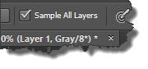
This is necessary because we will paint on an empty layer. This way, the content of the layers further down the stack are included in the result.

- To remove small flecks just click on them. You may need to paint over larger flecks. This tool will do a good job on eliminating freckles, moles, and so on. The results may be improved upon by reducing the opacity of the layer.

Sharpen the person
- Use of the Unsharp mask
  - From film era
  - Corrects blurring
  - Recommend you use it
- Use magnetic lasso to select the person
- Choose the unsharp mask filter:
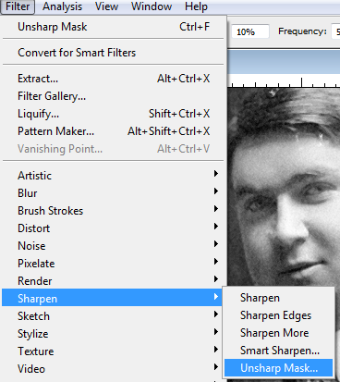

  - Properties:
    - Amount…around 150 for objects, less if a person, more if need a lot of detail…try 75 for person
    - Radius – number of surrounding pixels that are affected by sharpening…use 1
    - Threshold: 10 is a good value…
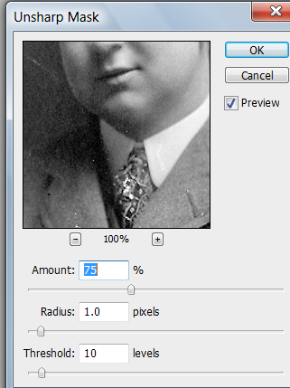
- Save as OldPictureFixed

Questions?

