Photoshop filters.doc rev 03/20/2015

Filters, fixing old Photographs

Open:
- Giz.jpg
- Old Image.jpg

Sharpening (portion of) a picture
- Switch to Giz.jpg
- Let’s sharpen the area around the cat’s mouth
- Create new layer from the Background, name it Gizmo (Recall other ways to rename Background?)
- Select his face using your favorite tool…I used lasso
- Feather by 5 pixels
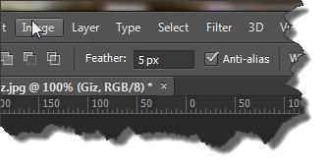
Or Select>Modify>Feather
- Choose Filter>Sharpen>Unsharp mask
- Use these values: Amount: 80%, Radius: 1.0, Threshold: 10
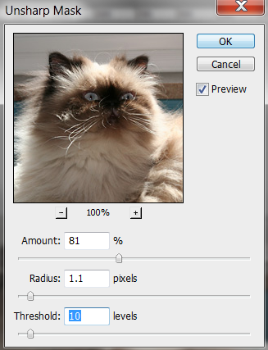

Rules of thumb: 75-100 for Amount (less for people, more for objects), 1 for Radius and 10 for Threshold
- Save as CatSharpened.psd
- Close

Filters: Fixing old photographs
- Remove scratches using a noise filter
- Sharpen
- Healing Brush

- Open/switch to Old Image.jpg
- Let’s delete some of the dust and scratches
  - Filter>Noise>Dust and Scratches

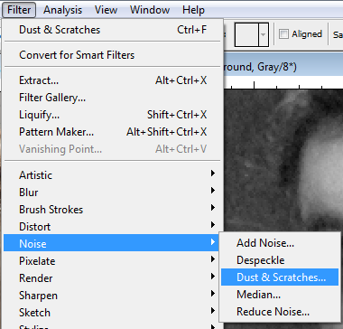

- Adjust the Radius and Threshold properties (be sure Preview is checked)
- Here are my values:

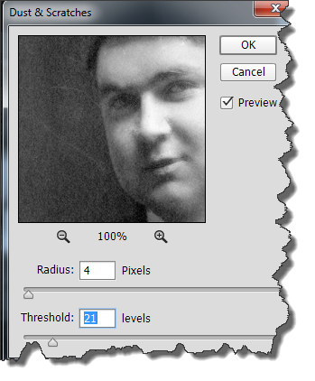
You can move the image around, zoom in/out

- Use the healing brush to remove the remaining particles….you’re experts by now so no need to show again!

Sharpen the person only
- Unsharp mask
  - From film era
  - Corrects blurring
  - Recommend you use it
- Use magnetic lasso to select the person
- Choose the unsharp mask filter:
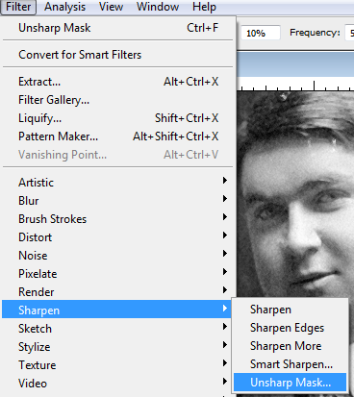

  - Properties:
    - Amount…around 150 for objects, less if a person, more if need a lot of detail…try 75 for person
    - Radius – number of surrounding pixels that are affected by sharpening…use 1
    - Threshold: 10 is a good value…
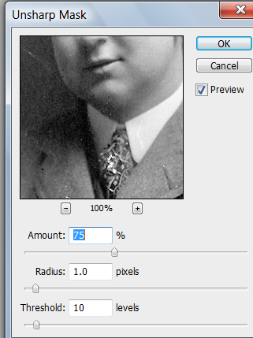
- Save as OldPictureFixed

Questions?

